

BOIKANYO RANKAPOLE
APHELELE NOMBILA
International Finance Article
U.S. Economic Uncertainty and the Distribution of Capital Flows: A Quantile Regression Extension of Du & Pu (2025)
Master of Financial Engineering
University of Johannesburg: School of Economics

Abstract
By analysing the effects of U.S. economic policy uncertainty on capital flows in ten emerging market economies from 1998 to 2022, this study extends the work of Du and Pu (2025) by providing a more nuanced understanding of capital movement dynamics. Unlike Du and Pu, who focused on extreme capital-flow incidents using a binary logit model, this paper utilizes continuous measures of net inflows and outflows, employing quantile regression alongside Ordinary Least Squares (OLS) to capture heterogeneous effects across the distribution of capital flows. The study incorporates a comprehensive panel dataset and accounts for various control variables, including global commodity prices and domestic macroeconomic indicators.
The quantile regression results reveal significant findings: at the 10th percentile, financial uncertainty greatly reduces capital inflows, indicating a deterrent effect during periods of weak investment. Additionally, macroeconomic uncertainty exhibits a notable quantile gradient for capital outflows, suggesting that pronounced capital flight is increasingly linked to U.S. uncertainty more than typical outflow levels. The study also shows that different types of uncertainty have conflicting effects; macro uncertainty tends to diminish outflows, whereas actual uncertainty tends to raise them. This demonstrates the complexity and source dependence of investor behaviour.

Contents
Abstract 1
Chapter 1: Introduction 3
1.1 Background and Motivation 3
1.2 Problem Statement 4
1.3 Objectives of the Study 5
1.4 Contributions of the Study 5
1.5 Structure of the Study 6
Chapter 2: Literature Review 6
2.1 Theoretical Framework 6
2.1.1 Global Financial Cycle 6
2.1.2 Uncertainty Channel 7
2.1.3 Push–Pull Framework 7
2.2 Empirical Review 7
2.2.1 Effects of Uncertainty Shocks on Macro-Financial Stability 7
2.2.2 Determinants of Extreme Capital-Flow Episodes 8
2.2.3 Exchange Rate Regimes and Heterogeneity 8
2.3 Research Gap and Contribution 9
2.3.1 Identified Gaps 9
2.3.2 This Study’s Contribution 9
Chapter 3: Methodology 10
3.1 Data 10
3.1.1 Dependent Variables: Extreme Capital Flow Episodes 10
3.1.2 U.S. Economic Uncertainty 11
3.1.3 Control Variables 12
3.2 Model Specification 12
3.3 Econometric Technique 14
3.3.1 Pre-Estimation 14
3.3.2 Estimation 15
3.3.3 Post-Estimation 16
Chapter 4: Empirical Results 18
4.1 Descriptive Statistics and Cross Correlation 18
4.1.1 Descriptive Statistics 18
4.1.2 Correlation Matrix 19
4.2 Baseline Model: OLS 20
4.3 Quantile Regression 21
4.4 Diagnostic Tests 23
4.4.1 OLS Diagnostics 23
4.4.2 Quantile Regression Diagnostics 24
4.5 Robustness Tests 25
4.6 Overview of the Results 26
Chapter 5: Conclusion 28
5.1 Policy Implications 28
References 29
Appendix A: Quantile Regression Results and Graphical Analysis 32

Chapter 1: Introduction

1.1 Background and Motivation
International capital flows are a crucial feature of globalisation since they finance investment, promote financial integration, and accelerate growth, especially in emerging and developing economies (EMDEs). However, their unpredictable nature remains a major policy challenge. Abrupt stops, also referred to as sharp reversals in capital inflows, have often resulted in currency depreciation, liquidity crises, and macroeconomic instability in financially open nations. Events like as the Global Financial Crisis (2008–09), the COVID-19 pandemic (2020), and the Taper Tantrum (2013) demonstrate how shocks that originate in major financial hubs, particularly the U.S., can swiftly spread throughout EMDEs.
A growing body of research attributes this movement to the Global Financial Cycle (GFC) (Rey, 2015), which links coordinated shifts in credit, asset prices, and capital flows to global liquidity, risk perception, and U.S. monetary policy. This theory states that U.S. financial conditions and global risk aversion are the two primary push factors affecting capital reallocation globally.
Another crucial channel is uncertainty. When uncertainty rises, whether due to policy ambiguity, financial-market stress, or macroeconomic volatility, investors become more risk averse, delay investments, and leave riskier markets (Bloom, 2009; Akinci et. At., 2022). These effects are more noticeable in economies with poor buffers or defective financial markets because uncertainty tightens financial conditions and raises capital-flow volatility.
Simplified data demonstrate that drops in net private capital inflows to EMDEs frequently occur during times of increased U.S. uncertainty. The effects vary, too, with some economies seeing significant outflows and others remaining mostly unaffected. This variability emphasises the significance of comprehending distributional dynamics as well as average effects how uncertainty impacts the full spectrum of capital-flow outcomes, from mild oscillations to severe crises.

1.2 Problem Statement
By empirically measuring the effects of U.S. economic uncertainty shocks on extreme capital-flow episodes sudden halt, surges, retrenchments, and flights across 71 EMDEs, Du and Pu (2025) significantly advance the field. Using a panel logit framework, they discover that increased U.S. uncertainty highlights the global transmission of U.S. uncertainty through the financial system by decreasing the likelihood of capital inflow surges and increasing the likelihood of outflow episodes.
Although useful, the Du and Pu (2025) study concentrates on the likelihood of severe events, which is simply a dichotomy of crises and non-crises. Such an approach does not capture the strength of the response of capital flows throughout the wider distribution, but it does capture if a severe episode happens. Capital inflows and outflows as a percentage of GDP are represented by the continuous dependent variable in this extension. As a result, a logit specification is inappropriate.
The baseline model used to quantify the average or mean impact of U.S. uncertainty shocks on capital flows is Ordinary Least Squares (OLS). Nevertheless, significant asymmetries may be obscured by mean-based models: uncertainty shocks may have disproportionately substantial effects during times of high inflows or outflows. In order to investigate whether uncertainty effects vary throughout the distribution and to capture potential non-linearities and tail dynamics in capital-flow responses, a quantile-regression approach is presented.

1.3 Objectives of the Study
The main goal of this research is to build on Du and Pu's (2025) findings by investigating the ways in which economic uncertainty shocks in the United States affect the dynamics of capital flow distribution in emerging and developing nations. The research focusses on how uncertainty impacts the volume of flows across their whole conditional distribution, rather than just whether it raises the probability of extreme events.
The study uses panel quantile regression to examine whether the impacts of uncertainty are more uniform across all quantiles or concentrated in the distribution's tails, which capture dramatic instances of surges and halt. Additionally, the study makes a distinction between real, macroeconomic, and financial uncertainty, offering a more detailed understanding of how various aspects of uncertainty spread internationally.
Ten sample emerging and developing economies Brazil, Mexico, India, Indonesia, Thailand, South Korea, South Africa, Turkey, Poland, and Chile are the subject of the empirical analysis. These nations were chosen based on their financial openness, data accessibility, and past exposure to shocks from the United States and other countries.

1.4 Contributions of the Study
This study makes several significant contributions to the literature on international finance. By integrating panel quantile regression and OLS approaches into a single analytical framework, it first advances methodology. Quantile regression enables a more thorough examination of how these effects differ at various degrees of inflows and outflows, whereas OLS determines the baseline mean link between U.S. uncertainty and capital flows.
Second, the results provide fresh perspectives on how global uncertainty affects distribution. According to the findings, financial uncertainty acts as a deterrent during times of already poor investment by drastically lowering capital inflows at the 10th percentile. On the other hand, outflows at higher quantiles show an increasingly negative effect from macroeconomic uncertainty, suggesting that U.S. uncertainty mainly aggravates large-scale capital flight rather than typical flow fluctuations.
Third, the study reveals complex investor behaviour by distinguishing between distinct forms of uncertainty. Investors respond differently depending on the source and type of uncertainty, as evidenced by the fact that real uncertainty raises outflows while macroeconomic uncertainty decreases them. These findings contribute to a better understanding of how global shocks reach EMDEs.
Finally, the findings have significant policy ramifications. When formulating macroprudential and reserve policies, policymakers should give tail-risk reduction precedence over average volatility control because uncertainty shocks disproportionately impact the tails of the capital-flow distribution. Resilience against shocks of global uncertainty requires maintaining enough foreign reserves, fortifying financial buffers, and boosting institutional credibility.

1.5 Structure of the Study
This dissertation's remaining sections are organised as follows. An extensive survey of theoretical and empirical literature is provided in Chapter 2, which covers topics such as push-pull frameworks in capital-flow analysis, the Global Financial Cycle, and the pathways via which uncertainty is transmitted. The data, variable creation, and econometric methods are covered in Chapter 3, with a focus on how the quantile-regression approach builds upon Du and Pu's (2025) basic paradigm. The empirical results are reported and interpreted in Chapter 4, which also highlights variation among uncertainty categories and nation factors by comparing OLS and quantile results. The study is finally ended in Chapter 5, which also offers policy implications, a summary of the key findings, and recommendations for future research on the distributional impacts of global uncertainty shocks.

Chapter 2: Literature Review

2.1 Theoretical Framework
The Global Financial Cycle (GFC), the uncertainty channel, and the push-pull framework are three complementary theoretical frameworks that are used in this study to understand how U.S. economic uncertainty shocks transmit into cross-border capital flows, especially their effects on the tails of the distribution, such as abrupt stops and large surges.

2.1.1 Global Financial Cycle
According to Rey (2015)'s proposal of the Global Financial Cycle (GFC), a collection of global financial factors often originating in major financial centres like the United States drive cross-border co-movement in capital flows, leverage, and asset prices. Global capital flows move in unison because of these shocks, which are transmitted through shifts in risk aversion, global liquidity, and U.S. monetary policy.
Domestic factors including financial openness, foreign reserves, and external indebtedness influence how a nation reacts. By separating transmission during crisis and non-crisis times and emphasising exposure heterogeneity, more recent research improves on the GFC hypothesis. The Global Financial Cycle and Capital Flows, for example Countries' sensitivity to global financial shocks varied significantly during the COVID-19 Pandemic (Davis and Zlate, 2023), contingent on institutional quality and exchange rate flexibility.
Here, Du and Pu (2025) show that a major push factor, U.S. economic uncertainty, functions as a global financial cycle shock that raises the likelihood of severe capital-flow episodes (such as abrupt halts and layoffs) in 71 emerging and developing economies (EMDEs).

2.1.2 Uncertainty Channel
The uncertainty channel was formalised by Bloom (2009), and it states that greater uncertainty tightens financial conditions, delays investment, and raises risk aversion. Uncertainty in the U.S. can cause global risk premia to rise and lead to a reallocation of portfolios away from riskier emerging-market assets in international contexts.
In a two-country model, Akinci, Kalemli-Özcan, and Queralto (2022) demonstrate that U.S. uncertainty shocks lower international capital flows through financial intermediaries and raise worldwide risk premia. Similarly, Palmén (2022) shows that financial shocks and uncertainty have both independent and interactive effects on investment and production using a non-Gaussian VAR.
These impacts are magnified when paired with financial frictions like intermediary leverage and credit limitations. This methodology is adopted by Du and Pu (2025), who interpret results using the macro-uncertainty and financial-friction mechanism, and who use the Jurado et al. (2015) uncertainty index as their proxy for U.S. uncertainty.

2.1.3 Push–Pull Framework
Capital flow drivers are divided into two categories by the push-pull paradigm (Fernandez-Arias, 1996): pull factors, which are domestic fundamentals like GDP growth, inflation, and institutional quality; and push factors, which are external/global variables like U.S. interest rates, global liquidity, and U.S. uncertainty.
Both channels are integrated in recent studies. According to Carrera, Montes-Rojas, and Toledo (2021), terms of trade moderate the link between commodities exporters' and importers' sensitivity to global liquidity shocks. In a similar vein, Du and Pu (2025) show how U.S. shocks interact with local factors to affect capital-flow dynamics across exchange rate regimes by including both push (U.S. uncertainty) and pull (domestic fundamentals) variables in their empirical framework.

2.2 Empirical Review

2.2.1 Effects of Uncertainty Shocks on Macro-Financial Stability
The importance of uncertainty shocks in causing macro-financial instability has been highlighted in recent empirical research. Using a structural VAR, Caldara, Fuentes-Albero, Gilchrist, and Zakrajšek (2016) discover that uncertainty and financial shocks both have a major impact on business-cycle variations, with the latter being especially harmful during times of tight financial conditions.
While Akinci et al. (2022) show through a theoretical two-country model that U.S. uncertainty raises global risk premia and depresses foreign capital flows, Palmén (2022) uses a non-Gaussian VAR framework to show that uncertainty shocks have long-lasting consequences on investment and production.
Uncertainty shocks increase credit spreads and financial-market volatility, according to recent empirical research (Journal of Empirical Finance, 2023). In this regard, Du and Pu (2025) provide further evidence that the likelihood of dramatic capital-flow reversals is greatly increased by U.S. uncertainty, thus connecting macro-level uncertainty to financial instability in developing countries.

2.2.2 Determinants of Extreme Capital-Flow Episodes
The causes of instances of excessive capital flow surges, halts, retrenchments, and flight have been re-examined in post-crisis studies. Forbes and Warnock (2021) extend earlier research by showing that there is a higher correlation between exceptional capital-flow events and global risk indicators, even if the frequency of these events hasn't increased significantly since the Global Financial Crisis.
According to studies like Cerutti, Claessens, and Puy (2019), the main push factors for capital flow volatility are global risk aversion, liquidity, and U.S. monetary policy. On the other hand, Ghosh, Ostry, and Qureshi (2015) emphasise that changes in domestic fundamentals, such as debt structures, exchange-rate regimes, and reserves, determine how external shocks translate into extremes in capital movement.
By using a panel logit model to analyse 71 EMDEs, Du and Pu (2025) explicitly contribute to this strand by demonstrating that U.S. uncertainty shocks raise the likelihood of abrupt halt and retrenchments while decreasing the probability of surges. Their findings hold up well across financial account components and subsamples.

2.2.3 Exchange Rate Regimes and Heterogeneity
It is still unclear from the studies whether floating exchange-rate regimes provide protection against global financial shocks. According to Rey (2015) and Miranda-Agrippino and Rey (2015), the traditional "trilemma" during the GFC dissolves into a "dilemma": when global financial conditions dominate, countries cannot achieve monetary independence regardless of exchange-rate flexibility.
Empirical evidence indicates that global circumstances often overshadow the protective effect of exchange-rate regimes (Cerutti et al., 2019; Carrera et al., 2021). Du and Pu (2025) directly tested this variability and found that floating regimes do not significantly reduce the impact of U.S. uncertainty shocks. In some cases, they make significant capital flow reversals more likely, which suggests inadequate defence against global shocks.

2.3 Research Gap and Contribution

2.3.1 Identified Gaps
Average versus distributional effects: Most studies, including Du and Pu (2025), concentrate on the likelihood of severe events or average (mean) reactions. The possible differential effects of U.S. uncertainty on certain quantiles of the capital-flow distribution which might be more noticeable in the tails than in the median area are disregarded by this approach.
Tail behaviour and magnitude: Although some research classify extreme events (such surges or halts), few employ quantile regression or extremal-quantile approaches to investigate how uncertainty impacts the amplitude of flows conditional on being in the tails. These methods can demonstrate if uncertainty disproportionately exacerbates excessive inflows or outflows.
Comparing quantile impacts between times of crisis and times when there is no crisis is still uncommon. To examine whether tail sensitivity to U.S. uncertainty increases at times of global stress (e.g., 2008–09, 2020), it offers new data on nonlinearities in shock transmission.
Heterogeneity in the tails: Although some studies have looked at exchange-rate regime differences, little is known about how other characteristics, such as financial openness, reserve sufficiency, debt levels, or institutional quality, affect tail behaviour.
Methodological innovation: Push-pull frameworks are infrequently employed in international capital-flow studies, even though quantile techniques have gained popularity in banking. Extreme quantile regression (Chernozhukov, Fernández-Val, and Kaji, 2021) provides tools for trustworthy inference in the tails, despite their underutilisation.

2.3.2 This Study’s Contribution
To close these gaps, the current research uses panel quantile regression to assess how U.S. economic uncertainty affects the amount and likelihood of capital flow fluctuations across quantiles. This expands on the work of Du and Pu (2025). Focussing on ten developing and expanding economies Brazil, Mexico, India, Indonesia, Thailand, South Korea, South Africa, Turkey, Poland, and Chile maintains regional representativeness while maintaining consistent data coverage and financial-market openness.
Several contributions are provided by this methodological extension:
Distributional evidence: Quantile regression determines if impacts cluster in the tails by calculating the impact of U.S. uncertainty on capital flows throughout the whole conditional distribution.
Analysis of heterogeneity: Whether domestic characteristics increase or decrease tail effects depends on interactions with exchange-rate regimes, reserve ratios, and financial openness.
Comparing calm and crisis: Separate estimates of quantile sensitivity for state-dependent asymmetries are made for calm and crisis times.
A deeper understanding of how global shocks affect the amount and intensity of capital-flow volatility in different economies can be gained using fixed-effects panel quantile regression and extremal-quantile inference.

Chapter 3: Methodology

3.1 Data
The study uses quarterly data ranging from 1998 to 2022 for 10 emerging economies (Brazil, Chile, Indonesia, India, Mexico, Poland, South Africa, South Korea, Thailand, Turkey). Since this is an extension with partial replication of the paper by Du and Pu (2025), the variables used are identical with minor differences in the dependent variables.

3.1.1 Dependent Variables: Extreme Capital Flow Episodes
In order to capture the dynamics of gross capital flows, it is imperative to focus on both net capital flows and gross capital flows (Forbes and Warnock, 2012). This study follows the same logic, we captured gross capital inflow and gross capital outflow data from International Monetary Fund (IMF) (2025) database. Gross capital inflows are the sum of portfolio liabilities, other investment liabilities, and financial derivatives. Gross capital outflows are the sum of portfolio assets, other investment assets, and financial derivative assets. Net inflows are calculated by subtracting gross outflows from gross inflows.
This analytical approach highly differs from the binary extreme-episode framework employed by Du and Pu (2025). Their methodology identifies capital flow events through threshold-based classification of extreme episodes, our quantile regression analysis examines the continuous distribution of capital flows across their entire range. Rather than categorizing flows into discrete states of 'surges,' 'stops,' 'flight,' or 'retrenchment,' we estimate how determinants differentially affect capital movements at various points of the flow distribution, from the 10th to the 90th percentiles. This continuous distributional approach captures nuanced effects that binary classifications may obscure, particularly for moderate but economically significant flow variations. By analyzing the complete spectrum of capital movements rather than focusing exclusively on tail events, we provide a more comprehensive understanding of how U.S. uncertainty shocks transmit to emerging market capital flows across normal and extreme market conditions alike. This methodological advancement reveals heterogeneity in uncertainty effects that would remain hidden under conventional extreme-episode frameworks.

3.1.2 U.S. Economic Uncertainty
The uncertainty variables for this study are selected from Judaro et al. (2015) index. These indices provide a robust, data-driven measures of economic uncertainty. Contrary to earlier proxies based on stock market volatility or news-based policy indices, the JLN methodology defines uncertainty as the conditional volatility of the unpredictable component of a vast number of economic time series. The process begins by forecasting hundreds of economic indicators $(y_{j,t})$ using their common factors. The common error for a horizon h is $y_{j,t+h}-E\left[y_{j,t+h}|I_{t})\right]$, where $I_{t}$ is the information set at time t. the uncertainty for j is then the conditional expectation of the squared, unpredictable component:
$U_{jt}^{y}(h)≡\sqrt{y_{j,t+h}-E\left[{\left(y_{j,t+h}-E\left[y_{j,t+h}|I_{t})\right]\right)}^{2}|I_{t}\right]},$ (1)
The aggregate macroeconomic uncertainty index $U_{jt}^{y}(h)$ is constructed by taking a weighted average of these individual uncertainties across all series $j=1,...,N_{y}$. A key innovation of JLN is their further decomposition of this aggregate uncertainty into distinct categories which are, macro, real, and financial, by grouping the underlying series based on their economic nature. This allows us to move beyond a single, monolithic uncertainty measure and instead investigate the specific channels through which different types of uncertainty propagate.
Our study extends the work of Du and Pu (2025) by leveraging this multi-faceted uncertainty framework. While their study uses a single, aggregate U.S. economic uncertainty index, we disaggregate the effects by examining the distinct roles of macro, real, and financial uncertainty shocks. This is a critical advancement, as these uncertainty types originate from different sectors of the economy and are likely transmitted through different channels to international capital flows. For instance, financial uncertainty, often linked to banking stress and asset price volatility, may trigger rapid retrenchment by global banks and institutional investors. In contrast, real uncertainty, pertaining to future consumption and investment demand, might have a more pronounced effect on foreign direct investment decisions. By analyzing these components separately, our paper provides a more refined and granular understanding of the drivers of extreme capital flow episodes, moving beyond the aggregate "push factor" examined in prior literature to identify the specific nature of the uncertainty shock that matters most for financial stability in emerging markets.
Similar to Du and Pu (2025), our study selects a 3-step horizon (h=3) as the benchmark measure of uncertainty. Because the uncertainty index is computed monthly, and our analysis is quarterly, the monthly values are converted to quarterly values by applying a weighted average given by:
${Uncertainty}_{jt}=\frac{3U_{jt}^{y}(h)+2U_{jt-1}^{y}(h)+U_{jt-2}^{y}(h)}{6}$ (2)
For robustness tests, we will use the simple arithmetic mean.

3.1.3 Control Variables
Following our theoretical underpinnings, the push–pull and the GFC, our model incorporates a comprehensive set of control variables to isolate the specific effect of U.S. uncertainty shocks. The domestic ‘pull’ factors, which determine an economy's inherent attractiveness to capital, include financial openness, measured by the Chinn-Ito index (Chinn and Ito, 2006) where a higher value indicates fewer capital controls; the quarterly change in the bilateral exchange rate against the U.S.; the real Gross Domestic Product (GDP) growth rate; the inflation rate based on the Consumer Price Index (CPI); the level of economic development measured by GDP per capita; and the ratio of international reserves to GDP, which captures a country's buffer against capital flow volatility (Forbes and Warnock, 2012). The international ‘push’ factors, which represent the global financial backdrop, include the change in the U.S. federal funds rate, a primary transmitter of the GFC; the log of crude oil prices; and a global commodity price index. This selection aligns with and extends the controls used in related work, such as Du and Pu (2025), by ensuring we robustly account for both the domestic absorption capacity and the global monetary and commodity cycles that concurrently influence capital flows alongside uncertainty.

3.2 Model Specification
This study employs a panel quantile regression to analyze how U.S. uncertainty shocks affect the entire distribution of capital flows in emerging markets. Our model specification, adopted from Koenker (2004), is given as:
$Q_{τ}(Y_{i,t})=β_{0}(τ)+β_{1}(τ){MUnc}_{US,t-1}+β_{2}(τ){RUnc}_{US,t-1}+β_{3}(τ){FUnc}_{US,t-1}+α\left(τ\right){kopen}_{i,t}+δ(τ)X_{i,t-1}^{'}+μ_{i}+ε_{i,t}$ (4)

Where $Q_{τ}(Y_{i,t})$ is the $τ$-th quantile of capital flows for country I at time t; ${MUnc}_{US,t-1}, {RUnc}_{US,t-1}, {FUnc}_{US,t-1}$ are the U.S. macro, real, and financial uncertainties; $X_{i,t-1}^{'}$ is the vector of the continuous control variables; $β_{1}(τ) to β_{3}(τ)$, $α(τ), and$ $δ(τ)$ are the coefficients of uncertainty effects, financial account openness effects, and continuous control variables, respectively; $μ_{i}$ represents the country fixed effects; $ε_{i,t}$ is the error term. All continuous explanatory variables are lagged one quarter (t-1) to mitigate reverse causality concerns. This approach allows us to test whether uncertainty effects vary across normal and extreme capital flow conditions within the context of the GFC (Rey, 2015).
Drawing on the GFC and uncertainty transmission literature, we hypothesize that U.S. uncertainty shocks will predominantly reduce capital inflows to emerging markets, particularly at the lower quantiles, as risk aversion rises and global risk appetite contracts. However, following the 'flight to quality' phenomenon documented by Forbes and Warnock (2012), we anticipate that financial uncertainty may simultaneously increase outflows from emerging markets at upper quantiles as domestic investors seek safer havens. The push-pull framework suggests domestic factors like GDP growth and international reserves should attract inflows across all quantiles, while U.S. interest rate increases are expected to trigger outflows, consistent with the monetary policy spillover channels emphasized by Miranda-Agrippino and Rey (2022). Building on Jurado et al.'s (2015) uncertainty decomposition, we further expect differential effects across uncertainty types, with financial uncertainty having the most pronounced impact on portfolio flows and real uncertainty affecting longer-term investment decisions.
Table 1 in the following page summarises our variables.
Table 1: Variables Summary
 | Variable | Symbol | Description | Source | Expected Relation
Dependent Variable(s) | Gross Inflows | $${GI}_{i,t}$$ | Total foreign investment into the country | IMF
 | Gross Outflows | $${GO}_{i,t}$$ | Total domestic investment abroad | IMF
 | Net Outflows | $${NI}_{i,t}$$ | Net foreign financing | IMF
Explanatory Variable(s) | Macro Uncertainty | $${MUnc}_{USA,t-1}$$ | Uncertainty in broad U.S. economic indicators | See Jurado et al. (2015) | -
 | Real Uncertainty | $${RUnc}_{USA,t-1}$$ | Uncertainty in U.S. real activity and labor markets | See Jurado et al. (2015) | -
 | Financial Uncertainty | $${FUnc}_{USA,t-1}$$ | Uncertainty in U.S. financial markets and conditions | See Jurado et al. (2015) | -
Control Variables | KOPEN | $${kopen}_{i,t}$$ | Degree of financial account opennes | https://web.pdx.edu/_ito/Chinn-Ito_website.htm | +
 | GDP per capita | $${GDPpc}_{i,t-1}$$ | Economic development level | IMF | +
 | GDP Growth | $${GDPg}_{i,t-1}$$ | Quarterly real economic growth rate | IMF | +
 | CPI | $${CPI}_{i,t-1}$$ | Consumer price index | IMF | -
 | Exchange Rate |  | Domestic currency per U.S. dollar | IMF | +
 | Reserves | $${Res}_{i,t-1}$$ | Foreign exchange reserves scaled by GDP | IMF | +
 | IR Change | $${Fed}_{i,t-1}$$ | Quarterly change in U.S. federal funds rate | IMF | -
 | Lnoil | $${lnoil}_{i,t-1}$$ | Log of Intermediate crude oil price | IMF | +/-
 | Commodity | $${Com}_{i,t-1}$$ | Global commodity price index | IMF | +/-
Source: Authors’ Own

3.3 Econometric Technique
This is a quantitative research study; therefore, econometric technique is employed. As previously mentioned, this paper employs a panel quantile regression model. This is because the model helps to examine whether the impacts of uncertainty are more uniform across all quantiles or concentrated in the distribution's tails which capture dramatic instances of surges and halt. This is imperative because the influence of uncertainty shocks is likely heterogeneous and may be most pronounced during extreme capital flow episodes (Adrian et al., 2019; Forbes and Warnock, 2012).
In order for our study to be statistically sound and reliable, we have to do pre-estimation and post-estimation tests.

3.3.1 Pre-Estimation

Winsorization
Extreme outliers can prove to be problematic for the nature of our study, therefore, we have to mitigate their influence while preserving the size of the sample and distributional shape of the data. To achieve this, we apply 1% symmetric winsorization, following the approached proposed by Winsor (1940). This non-parametric technique is standard in financial econometrics to reduce the bias induced by influential observations without discarding them entirely (Bollen and Pool, 2009). We can mathematically express this as:
$z^{w}=\left\{\begin{aligned}P_{01} \\ z \\ P_{99} \end{aligned}\begin{matrix}if z≤P_{01} \\ if P_{01}<z<P_{99} \\ if z≥ P_{99}\end{matrix}\right.$ (5)
Where $z^{w}$ represents the winsorized variables which are the dependent variables, and all explanatory variables except financial account openness because it is an ordinal index with discrete values; $P_{01}$ and $P_{99}$ represent the 1st and 99th percentiles of our variables’ distribution, respectively.

Descriptive Statistics and Correlation Matrix
In order to see if our dataset meets the necessary statistical assumptions, we will compute comprehensive descriptive statistics for all variables to verify data quality and identify potential outliers or data entry errors. After that, we will examine pairwise correlation coefficients between all explanatory variables to detect potential multicollinearity issues that could inflate standard errors and compromise inference (Wooldridge, 2010).

3.3.2 Estimation

Base Model: Ordinary Least Squares
This study employs the OLS as the baseline model. This approach is identical to that of Du and Pu (2025) who also employ the OLS as the baseline model for their analysis. OLS provides a good source of comparison for our quantile regression results, which allows for examination of how distributional effects differ from conditional mean relationships (Koenker and Hallock, 2001). Our OLS model is specified as:
$Y_{i,t}=θ_{0}+θ_{1}{MUnc}_{US,t-1}+θ_{2}{RUnc}_{US,t-1}+θ_{3}{FUnc}_{US,t-1}+X_{i,t-1}^{'}γ+ϵ_{i,t}$ (6)
Where $Y_{i,t-1}$ are country i’s capital flow measure in quarter t-1; $θ_{0}$ is the constant coefficient; $θ_{1}, θ_{2}, θ_{3}$ are the coefficients for the U.S. uncertainty variables; $γ$ is the coefficient for the control variables vector; $ϵ_{i,t}$is the error term.

Main Model: Quantile Regression
To fully capture heterogenous effects of U.S. uncertainty across the distribution of capital flows, we estimate panel quantile regressions as specified in equation (4).
$$Q_{τ}(Y_{i,t})=β_{0}(τ)+β_{1}(τ){MUnc}_{US,t-1}+β_{2}(τ){RUnc}_{US,t-1}+β_{3}(τ){FUnc}_{US,t-1}+α\left(τ\right){kopen}_{i,t}+δ(τ)X_{i,t-1}^{'}+μ_{i}+ε_{i,t}$$
Developed by Koenker and Bassett (1978), quantile regression gives a more robust and comprehensive study than the OLS. Quantile regression models conditional distribution of the dependent variable, as compared to OLS which estimates conditional mean effects. By estimating models across multiple quantiles ($τ$ = 0.10, 0.25, 0.50, 0.75, 0.90), we can test for this heterogeneity directly. Furthermore, quantile regression is invariant to monotonic transformations of the dependent variable and is more robust to outliers and non-normal error distributions, which are common in financial flow data.
While Du and Pu (2025) make a significant contribution by analyzing extreme capital flow episodes, their binary classification imposes an arbitrary threshold and loses information about the intensity of flows within each category. Our quantile regression framework generalizes their approach by examining the entire continuous spectrum of capital flows. It allows us to confirm whether the effects they identify at the extremes are indeed distinct and to precisely quantify how the magnitude of these effects evolves across the flow distribution, from tranquil periods to extreme episodes.

3.3.3 Post-Estimation

Diagnostic Tests
Before we evaluate the results, it is very important that the estimated the models are in line or rather satisfy the assumptions that are underlying OLS as well as quantile regression estimation. Diagnostic testing increases the credibility of inference, verifies model appropriateness, and identifies possible misspecification (Gujarati and Porter, 2009; Wooldridge, 2020).
Multicollinearity: Variance Inflation Factor.
VIF is calculated for each regressor in the OLS baseline model to detect multicollinearity among the explanatory variables. This would mean that high correlation between independent variables leads to multicollinearity, which raises standard errors and decreases statistical significance (Kutner et al., 2005). However, a variance inflation factor with a score greater than 10 is often regarded to imply that the is severe multicollinearity (Gujarati and Porter, 2009).
Cross-Sectional Dependence
Examining whether residuals are associated across cross-sections is essential due to the dataset's panel format, which spans 10 emerging and developing economies throughout time. If overlooked, cross-sectional reliance may skew standard errors and result from unreported global shocks, financial connections, or policy spillovers (Pesaran, 2004; 2006). To find cross-sectional correlation in the OLS residuals, the Breusch–Pagan LM test and the Pesaran CD test are used. When dependency is found, inference is corrected using robust standard errors (either cluster-robust estimators or Driscoll-Kraay estimators) (Hoechle, 2007). Strong adjustments guarantee accurate statistical inference, yet the results show a modest reliance that is consistent with the impact of global financial forces.
Quantile-Regression Robustness: Residual Analysis
Traditional OLS diagnostics are not directly applicable since quantile regression (Koenker and Bassett, 1978) calculates conditional quantiles instead of the conditional mean and relaxes the homoskedasticity criterion. Rather, quantile-specific specification tests and residual analysis are used to evaluate the robustness of the model ( Koenker and Hallock, 2001; Koenker, 2005).
In order to verify that the fitted model accurately reflects variability in the conditional distribution of capital flows, the distribution of standardised residuals is first analysed across quantiles to make sure that no systematic patterns are left. Second, Wald-type tests for equality of slopes are used to assess the stability of computed coefficients over neighbouring quantiles (Koenker and Xiao, 2002). This confirms if there are notable differences in the link between U.S. uncertainty and capital flows at different distribution points.
Lastly, to check if the findings are not influenced by specific observations or time periods, robustness checks involve re-estimating the quantile models using different lag structures. The dependability of the quantile-regression results is supported by the constancy of coefficient signs and significance throughout various robustness tests.
All things considered, the diagnostic tests verify that the quantile-regression extensions and the OLS baseline are resilient to different model formulations, well-specified, and free of significant econometric violations.

Robustness Tests
To fully trust and prove that the results we obtained are reliable, we must employ alternative model specifications that draw the same conclusions. We cannot favour one inference over another without conducting sensitivity analysis (Learner, 1983). For our study, we employ two very well thought robustness tests.
As adopted from Du and Pu’s (2025) analysis, the first of our robustness tests is to substitute the weighted-average approach suggested by Jurado et al. (2015) with a straightforward arithmetic mean for quarterly aggregation when recalculating the U.S. uncertainty indices. This alternative specification examines how our findings are affected by the presumed temporal structure of uncertainty. The conclusion that our findings are motivated by the underlying economic relationship rather than by a particular and possibly arbitrary weighting scheme is strengthened if we obtain significant results.
Additionally, by estimating models at $τ$ = 0.05 and $τ$ = 0.95, we expand our quantile regression analysis to incorporate the extreme tails of the capital flow distribution. This accomplishes two goals. By explicitly modeling the 5% tails, it first directly responds to the literature on extreme capital flow episodes (Forbes and Warnock, 2012; Du and Pu, 2025), enabling us to confirm whether the effects we see at the 10th and 90th percentiles are even more pronounced during truly exceptional events. In order to make sure that the observed patterns of heterogeneity are not affected by the particular quantile selection looked at in our baseline model, it also tests the stability of the estimated quantile processes.

Chapter 4: Empirical Results

4.1 Descriptive Statistics and Cross Correlation

4.1.1 Descriptive Statistics
Table 2: Descriptive Statistics
Variable | N | Mean | SD | Min | Max
$${GI}_{i,t}$$ | 1000 | 2.15 | 8.87 | -30.86 | 43.17
$${GO}_{i,t}$$ | 1000 | 8.20 | 7.67 | 0.00 | 54.26
$${NI}_{i,t}$$ | 1000 | -6.06 | 10.25 | -63.71 | 32.06
$${MUnc}_{USA,t-1}$$ | 1000 | 0.81 | 0.12 | 0.67 | 1.28
$${RUnc}_{USA,t-1}$$ | 1000 | 0.75 | 0.11 | 0.66 | 1.32
$${FUnc}_{USA,t-1}$$ | 1000 | 0.97 | 0.15 | 0.72 | 1.39
$${kopen}_{i,t}$$ | 1000 | -0.01 | 0.95 | -2.00 | 2.00
$${GDPpc}_{i,t-1}$$ | 1000 | 8499.52 | 6852.05 | 413.63 | 35125.52
$${GDPg}_{i,t-1}$$ | 1000 | 3.53 | 3.48 | -13.13 | 11.47
$${CPI}_{i,t-1}$$ | 1000 | 105.63 | 48.84 | 8.06 | 542.44
$${Exch}_{i,t-1}$$ | 1000 | 1280.76 | 3317.56 | 0.26 | 14849.85
$${Res}_{i,t-1}$$ | 1000 | 0.03 | 0.06 | 0.00 | 0.31
$${Fed}_{i,t-1}$$ | 1000 | -0.02 | 0.46 | -1.44 | 1.47
$${lnoil}_{i,t-1}$$ | 1000 | 3.94 | 0.55 | 2.55 | 4.82
$${Com}_{i,t-1}$$ | 1000 | 180889.31 | 141680.37 | 34476.64 | 762669.05
Capital flow variables and reserves are measured in billions of USD. All other variables are in their original units

Source: Authors’ Own
Table 2 shows the descriptive statistics of our variables. The results show there is substantial heterogeneity in capital flow dynamics, the U.S. uncertainty variables as well as the control variables display some variation, capturing the diverse economic conditions across our sample. The significant standard deviations relative to means seen for most variables suggest substantial heterogeneity, making quantile regression particularly appropriate for capturing differential effects across the distribution of capital flows.

4.1.2 Correlation Matrix
Table 3: Correlation Matrix
 | $${GI}_{i,t}$$ | $${GO}_{i,t}$$ | $${NI}_{i,t}$$ | $${MUnc}_{USA,t-1}$$ | $${RUnc}_{USA,t-1}$$ | $${FUnc}_{USA,t-1}$$ | $${kopen}_{i,t}$$ | $${kopen}_{i,t}$$ | $${GDPpc}_{i,t-1}$$ | $${GDPg}_{i,t-1}$$ | $${CPI}_{i,t-1}$$ | $${Exch}_{i,t-1}$$ | $${Res}_{i,t-1}$$ | $${lnoil}_{i,t-1}$$ | $${Com}_{i,t-1}$$
$${GI}_{i,t}$$ | 1.00 | 0.24 | 0.69 | 0.02 | 0.05 | -0.03 | -0.10 | 0.04 | 0.18 | 0.13 | -0.08 | 0.46 | 0.07 | 0.08 | 0.11
$${GO}_{i,t}$$ | 0.24 | 1.00 | -0.54 | 0.14 | 0.26 | -0.07 | 0.04 | 0.30 | -0.05 | 0.39 | -0.08 | 0.36 | 0.03 | 0.33 | 0.41
$${NI}_{i,t}$$ | 0.69 | -0.54 | 1.00 | -0.09 | -0.16 | 0.03 | -0.12 | -0.19 | 0.19 | -0.18 | -0.01 | 0.13 | 0.04 | -0.18 | -0.21
$${MUnc}_{USA,t-1}$$ | 0.02 | 0.14 | -0.09 | 1.00 | 0.88 | 0.66 | 0.06 | 0.05 | -0.27 | 0.23 | 0.02 | 0.06 | -0.27 | 0.05 | 0.17
$${RUnc}_{USA,t-1}$$ | 0.05 | 0.26 | -0.16 | 0.88 | 1.00 | 0.51 | 0.06 | 0.14 | -0.31 | 0.41 | 0.04 | 0.08 | -0.18 | 0.08 | 0.33
$${FUnc}_{USA,t-1}$$ | -0.03 | -0.07 | 0.03 | 0.66 | 0.51 | 1.00 | -0.04 | -0.08 | -0.28 | 0.01 | 0.01 | -0.01 | -0.31 | -0.27 | -0.03
$${kopen}_{i,t}$$ | -0.10 | 0.04 | -0.12 | 0.06 | 0.06 | -0.04 | 1.00 | 0.52 | -0.06 | -0.08 | 0.20 | -0.34 | 0.01 | 0.15 | 0.08
$${GDPpc}_{i,t-1}$$ | 0.04 | 0.30 | -0.19 | 0.05 | 0.14 | -0.08 | 0.52 | 1.00 | -0.06 | 0.18 | -0.20 | -0.37 | 0.07 | 0.32 | 0.31
$${GDPg}_{i,t-1}$$ | 0.18 | -0.05 | 0.19 | -0.27 | -0.31 | -0.28 | -0.06 | -0.06 | 1.00 | 0.00 | 0.04 | 0.20 | 0.21 | 0.22 | 0.01
$${CPI}_{i,t-1}$$ | 0.13 | 0.39 | -0.18 | 0.23 | 0.41 | 0.01 | -0.08 | 0.18 | 0.00 | 1.00 | 0.01 | 0.12 | 0.20 | 0.41 | 0.71
$${Exch}_{i,t-1}$$ | -0.08 | -0.08 | -0.01 | 0.02 | 0.04 | 0.01 | 0.20 | -0.20 | 0.04 | 0.01 | 1.00 | -0.02 | 0.01 | 0.01 | 0.06
$${Res}_{i,t-1}$$ | 0.46 | 0.36 | 0.13 | 0.06 | 0.08 | -0.01 | -0.34 | -0.37 | 0.20 | 0.12 | -0.02 | 1.00 | 0.01 | 0.09 | 0.08
$${Fed}_{i,t-1}$$ | 0.07 | 0.03 | 0.04 | -0.27 | -0.18 | -0.31 | 0.01 | 0.07 | 0.21 | 0.20 | 0.01 | 0.01 | 1.00 | 0.19 | 0.36
$${lnoil}_{i,t-1}$$ | 0.08 | 0.33 | -0.18 | 0.05 | 0.08 | -0.27 | 0.15 | 0.32 | 0.22 | 0.41 | 0.01 | 0.09 | 0.19 | 1.00 | 0.53
$${Com}_{i,t-1}$$ | 0.11 | 0.41 | -0.21 | 0.17 | 0.33 | -0.03 | 0.08 | 0.31 | 0.01 | 0.71 | 0.06 | 0.08 | 0.36 | 0.53 | 1.00
Capital flow variables and reserves are measured in billions of USD. All other variables are in their original units

Source: Authors’ Own
Table 3 shows that our variables are statistically appropriate for what we want to achieve in this study. Most notably, all three uncertainty variables are positive and statistically significant as expected, are not excessively high, confirming that they capture distinct dimensions of uncertainty and can be included simultaneously without debilitating multicollinearity. With these preliminary checks validating the integrity of our dataset and the identification strategy, we can confidently proceed to the model estimation phase to uncover the causal, distributional effects of U.S. uncertainty shocks.

4.2 Baseline Model: OLS
Table 4: OLS Results
 | a) Gross Inflows |  | b) Gross Outflows |  | c) Net Inflows
 | Variable | Estimate | Variable | Estimate | Variable | Estimate
 | $${MUnc}_{USA,t-1}$$ | 4.30 (5.35) | $${MUnc}_{USA,t-1}$$ | -4.82 (4.07) | $${MUnc}_{USA,t-1}$$ | 9.11 (6.84)
 | $${RUnc}_{USA,t-1}$$ | -4.82 (5.36) | $${RUnc}_{USA,t-1}$$ | 9.30 (4.08)** | $${RUnc}_{USA,t-1}$$ | -14.12 (6.84)**
 | $${FUnc}_{USA,t-1}$$ | 0.17 (2.35) | $${FUnc}_{USA,t-1}$$ | -5.03 (1.79)*** | $${FUnc}_{USA,t-1}$$ | 5.20 (3.01)*
 | $${kopen}_{i,t}$$ | -0.41 (0.33) | $${kopen}_{i,t}$$ | -0.10 (0.25) | $${kopen}_{i,t}$$ | -0.31 (0.42)
 | $${GDPpc}_{i,t-1}$$ | 0.00038 (0.00)*** | $${Exch}_{i,t-1}$$ | 0.00 (0.00)*** | $${Exch}_{i,t-1}$$ | 0.00 (0.00)
 | $${GDPg}_{i,t-1}$$ | 0.23 (0.08)*** | $${GDPpc}_{i,t-1}$$ | -0.28 (0.06)*** | $${GDPpc}_{i,t-1}$$ | 0.51 (0.10)***
 | $${CPI}_{i,t-1}$$ | 0.01 (0.01)* | $${GDPg}_{i,t-1}$$ | 0.02 (0.01)*** | $${GDPg}_{i,t-1}$$ | -0.01 (0.01)
 | $${Exch}_{i,t-1}$$ | 0.00 (0.00) | $${CPI}_{i,t-1}$$ | 0.00 (0.00) | $${CPI}_{i,t-1}$$ | 0.00 (0.00)
 | $${Res}_{i,t-1}$$ | 79.52 (4.62)*** | $${Res}_{i,t-1}$$ | 61.57 (3.52)*** | $${Res}_{i,t-1}$$ | 17.95 (5.90)***
 | $${Fed}_{i,t-1}$$ | 0.90 (0.61) | $${Fed}_{i,t-1}$$ | -1.35 (0.47)*** | $${Fed}_{i,t-1}$$ | 2.25 (0.78)***
 | $${lnoil}_{i,t-1}$$ | -1.54 (0.60)** | $${lnoil}_{i,t-1}$$ | 0.90 (0.45)** | $${lnoil}_{i,t-1}$$ | -2.44 (0.76)***
 | $${Com}_{i,t-1}$$ | 0.00 (0.00) | $${Com}_{i,t-1}$$ | 0.00 (0.00)*** | $${Com}_{i,t-1}$$ | 9.11 (6.84)
 | $$θ_{0}$$ | 0.47 (3.18) | $$θ_{0}$$ | -1.54 (2.42) | $$θ_{0}$$ | 2.01 (4.06)
Coefficients represent the change in capital flows (billions USD) for a one-unit change in each independent variable. Significance levels: *** p < 1%, ** p <5%, * p <10%
Source: Authors’ Own
Table 4 shows results of our OLS base model with gross inflows, gross outflows, and net inflows as our dependent variables. From the table, it is depicted that the macro uncertainty variable is insignificant for all three dependent variables, implying that U.S. macroeconomic uncertainty has no effect on extreme capital flows. These findings are contrary to those of Du and Pu (2025), whose OLS results found uncertainty in the U.S. to have significant impact on extreme capital flows. Only real and financial uncertainty have significant impact, but only for gross outflows and net outflows. However, consistent with Du and Pu (2025), our results indicate that domestic fundamentals remain dominant drivers of capital movements. Specifically, GDP per capita and economic growth exert strong positive effects on both inflows and outflows, implying that stronger domestic performance attracts and enables more cross-border transactions.
Overall, the insignificance of the uncertainty variables in the mean regression highlights a limitation of the linear OLS framework. OLS masks distributional heterogeneity that may exist only in the tails of the capital flow distribution. This justifies the move toward quantile regression, which allows us to assess how U.S. uncertainty affects capital flows differently under normal versus extreme market conditions, aligning more closely with the emphasis of Du and Pu (2025) on tail behaviour.

4.3 Quantile Regression
Table 5: Quantile Regression Results
 | a) Gross Inflows |  |  |  |  |  | b) Gross Outflows |  |  |  |  |  | c) Net Inflows
 |  | τ=0.1 | τ=0.25 | τ=0.5 | τ=0.75 | τ=0.9 |  | τ=0.1 | τ=0.25 | τ=0.5 | τ=0.75 | τ=0.9 |  | τ=0.1 | τ=0.25 | τ=0.5 | τ=0.75 | τ=0.9
 | $${MUnc}_{USA,t-1}$$ | 11.66 | 7.82 | 8.07 | 6.64 | 20.79* | $${MUnc}_{USA,t-1}$$ | 1.78 | -1.27 | -9.23 | -16.70** | -16.48 | $${MUnc}_{USA,t-1}$$ | 15.41 | 10.73 | 11.77* | 3.29 | -6.14
 | $${RUnc}_{USA,t-1}$$ | -7.44 | -5.07 | -8.51 | -6.08 | -10.91 | $${RUnc}_{USA,t-1}$$ | -0.6 | 3.28 | 13.54* | 21.50*** | 27.27* | $${RUnc}_{USA,t-1}$$ | -15.83 | -13.82 | -19.61** | -11.47 | 4.13
 | $${FUnc}_{USA,t-1}$$ | -3.1 | -0.81 | -0.27 | 0.72 | -0.41 | $${FUnc}_{USA,t-1}$$ | -1.96 | -2.08* | -2.16 | -2.35 | -6.85* | $${FUnc}_{USA,t-1}$$ | 4.23 | 2.73 | 3.01* | 3.75 | 3.42
 | $${kopen}_{i,t}$$ | -0.13 | -0.22 | -0.11 | -0.4 | -0.88** | $${kopen}_{i,t}$$ | -0.05 | -0.11 | -0.28 | -0.17 | 0.29 | $${kopen}_{i,t}$$ | -1.42 | -0.12 | 0.60*** | -0.06 | -0.29
 | $${GDPpc}_{i,t-1}$$ | -0.00004 | 0.00016 | 0.00028*** | 0.00050*** | 0.00066*** | $${GDPpc}_{i,t-1}$$ | 0.12*** | 0.22*** | 0.37*** | 0.51*** | 0.54*** | $${GDPpc}_{i,t-1}$$ | -0.00013 | -0.00027** | -0.00017** | -0.00005 | 0.00001
 | $${GDPg}_{i,t-1}$$ | 0.28* | 0.29** | 0.13* | 0.06 | -0.04 | $${GDPg}_{i,t-1}$$ | -0.09*** | -0.14*** | -0.20** | -0.28*** | -0.42** | $${GDPg}_{i,t-1}$$ | 0.53** | 0.53*** | 0.22*** | 0.08 | 0.03
 | $${CPI}_{i,t-1}$$ | -0.05* | -0.02 | 0.01 | 0.02** | 0.01 | $${CPI}_{i,t-1}$$ | 0.0039 | 0.016** | 0.021 | 0.011 | 0.031 | $${CPI}_{i,t-1}$$ | -0.09*** | -0.04 | -0.02 | 0.016 | 0.024*
 | $${Exch}_{i,t-1}$$ | 0.00012 | 0.00001 | -0.00012* | -0.00015 | -0.00019 | $${Exch}_{i,t-1}$$ | 0.00001 | 0.00007 | 0.00006 | -0.00005 | -0.00018 | $${Exch}_{i,t-1}$$ | 0.00038* | -0.00009 | -0.00025*** | -0.00018 | -0.0002
 | $${Res}_{i,t-1}$$ | 0.04*** | 0.05*** | 0.06*** | 0.10*** | 0.13*** | $${Res}_{i,t-1}$$ | 0.03*** | 0.04*** | 0.06*** | 0.06*** | 0.07*** | $${Res}_{i,t-1}$$ | 0.01 | -0.0059 | 0.0067 | 0.020** | 0.034***
 | $${Fed}_{i,t-1}$$ | 1.83* | 1.71** | 0.21 | 0.61 | 2.06** | $${Fed}_{i,t-1}$$ | -0.21 | -0.35 | -0.69* | -0.8 | -1.51 | $${Fed}_{i,t-1}$$ | 4.12*** | 2.68** | 1.11* | 0.31 | 0.55
 | $${lnoil}_{i,t-1}$$ | -2.96*** | -2.38*** | -1.52** | -0.3 | -0.11 | $${lnoil}_{i,t-1}$$ | 0.39 | 0.83** | 0.9 | 2.24*** | 2.53* | $${lnoil}_{i,t-1}$$ | -3.94** | -3.29** | -1.93** | -0.44 | 1.29
 | $${Com}_{i,t-1}$$ | 0.000004 | 0.000001 | -0.000002 | -0.000004 | -0.000002 | $${Com}_{i,t-1}$$ | 0.005 | 0.0036* | 0.004 | 0.009* | 0.008 | $${Com}_{i,t-1}$$ | -0.012 | -0.0078 | -0.0021 | -0.006 | -0.0061
 | $$β_{0}(τ)$$ | 6.94 | 3.48 | 2.25 | -2.99 | -7.88 | $$β_{0}(τ)$$ | -1.02 | -3.52 | -4.59 | -6.8 | -5.11 | $$β_{0}(τ)$$ | 4.12 | 8.11 | 7.77 | 2.59 | -5.63
Coefficients represent the change in capital flows (billions USD) for a one-unit change in each independent variable. Significance levels: *** p < 1%, ** p <5%, * p <10%
Source: Authors’ Own estimates
Our model, as depicted in Table 5, reveals substantial heterogeneity in how U.S. uncertainty affects capital flows in emerging economies. While Du and Pu (2025) paper found uniformly negative effects of uncertainty on capital surges, Table 5(a) demonstrates that macroeconomic uncertainty stimulates large capital inflows at the $τ$=0.9, suggesting their binary approach may obscure important distributional nuances. Inversely, both real and financial uncertainty are negative but statistically insignificant coefficients across most quantiles, indicating a weak or a non-existing influence on gross inflows. The control variables show international reserves significantly positive on all quantiles, thus implying they are the biggest drivers of capital inflows. GDP per capita has stronger positive effects on higher quantiles, and GDP growth demonstrates significant positive impacts primarily at lower to median flow levels.
From Table 5(b), it can be seen that the relationship between uncertainty and gross capital outflows is more pronounced. Macroeconomic uncertainty exerts a significant negative effect at $τ$=0.5, $τ$=0.75 and $τ$=0.9, suggesting that investors tend to withhold outflows during episodes of extreme macroeconomic instability. Meanwhile, real uncertainty is positively associated with outflows at higher quantiles $τ$=0.5, $τ$=0.75 and $τ$=0.9, implying that real sector volatility prompts greater capital withdrawal. Financial uncertainty displays a negative and significant coefficient at the upper quantile (τ = 0.9), indicating that financial instability discourages capital flight, potentially due to liquidity constraints or policy interventions. Control variables paint a compelling picture of wealth-driven capital mobility, where GDP per capita exhibits remarkably strong positive effects across all quantiles, indicating that wealthier economies naturally engage in more substantial outward investment. International reserves again demonstrate powerful facilitation effects, though slightly less pronounced than for inflows.
These findings are broadly aligned with Du and Pu (2025), who found that U.S. economic uncertainty reduces the probability of extreme outflow episodes, consistent with a “flight-to-safety” or “wait-and-see” response among investors. However, their binary logit framework treats outflows as discrete extreme events, and our quantile approach uncovers that the deterring effect of U.S. uncertainty on outflows is concentrated mainly in the upper quantiles. This nuance reveals that uncertainty does not uniformly suppress outflows but becomes significant only when capital outflow pressures are already elevated, underscoring the asymmetric and nonlinear sensitivity of capital outflows to global uncertainty shocks.
For net capital inflows in Table 5(c), macro uncertainty coefficients are positive but not statistically significant across most quantiles. Real uncertainty shows a consistently negative and high significant effect at the median ($τ$=0.5), suggesting that heightened real sector volatility deters net inflows. Overall, we can say that real uncertainty is the primary channel through which uncertainty affects net inflows, while macro uncertainty weakly stimulates capital inflows at quantile $τ$=0.5. The control variable effects largely reflect the offsetting patterns observed in gross flows, with GDP growth emerging as the dominant positive driver across multiple quantiles, reinforcing that strong economic fundamentals attract net capital.
These results partially diverge from Du and Pu (2025), who observed that U.S. economic uncertainty significantly raises the likelihood of extreme inflow episodes. Our model reveals that once inflows and outflows are jointly considered, the net impact turns negative at central quantiles, dominated by the contractionary influence of real uncertainty. Hence, our findings refine their conclusion by showing that, although uncertainty can trigger inflow surges in the upper tail, it tends to reduce net inflows in normal or median conditions, reflecting a dampening effect on overall capital balance during periods of real-sector volatility.

4.4 Diagnostic Tests

4.4.1 OLS Diagnostics

Variance Inflation Factors
Table 6: VIF
a) Gross Inflows |  | b) Gross Outflows |  | c) Net Inflows
Variable | VIF Results | Variable | VIF Results | Variable | VIF Results
$${MUnc}_{USA,t-1}$$ | 7.169064478 | $${MUnc}_{USA,t-1}$$ | 7.169064478 | $${MUnc}_{USA,t-1}$$ | 7.169064478
$${RUnc}_{USA,t-1}$$ | 6.626094862 | $${RUnc}_{USA,t-1}$$ | 6.626094862 | $${RUnc}_{USA,t-1}$$ | 6.626094862
$${FUnc}_{USA,t-1}$$ | 2.23695928 | $${FUnc}_{USA,t-1}$$ | 2.23695928 | $${FUnc}_{USA,t-1}$$ | 2.23695928
$${kopen}_{i,t}$$ | 1.71995476 | $${kopen}_{i,t}$$ | 1.71995476 | $${kopen}_{i,t}$$ | 1.71995476
$${GDPpc}_{i,t-1}$$ | 2.144477365 | $${Exch}_{i,t-1}$$ | 2.144477365 | $${Exch}_{i,t-1}$$ | 2.144477365
$${GDPg}_{i,t-1}$$ | 1.305502171 | $${GDPpc}_{i,t-1}$$ | 1.305502171 | $${GDPpc}_{i,t-1}$$ | 1.305502171
$${CPI}_{i,t-1}$$ | 2.405215838 | $${GDPg}_{i,t-1}$$ | 2.405215838 | $${GDPg}_{i,t-1}$$ | 2.405215838
$${Exch}_{i,t-1}$$ | 1.270369575 | $${CPI}_{i,t-1}$$ | 1.270369575 | $${CPI}_{i,t-1}$$ | 1.270369575
$${Res}_{i,t-1}$$ | 1.379963873 | $${Res}_{i,t-1}$$ | 1.379963873 | $${Res}_{i,t-1}$$ | 1.379963873
$${Fed}_{i,t-1}$$ | 1.397872907 | $${Fed}_{i,t-1}$$ | 1.397872907 | $${Fed}_{i,t-1}$$ | 1.397872907
$${lnoil}_{i,t-1}$$ | 1.872404052 | $${lnoil}_{i,t-1}$$ | 1.872404052 | $${lnoil}_{i,t-1}$$ | 1.872404052
$${Com}_{i,t-1}$$ | 2.885901082 | $${Com}_{i,t-1}$$ | 2.885901082 | $${Com}_{i,t-1}$$ | 2.885901082
Source: Authors’ Own
From Table 6 above, the VIF results reveal that our OLS does not suffer from severe multicollinearity, with all values being substantially below the conventional threshold of 10 (Wooldridge, 2010), with the highest being 6.62 and 7.17 for macroeconomic uncertainty and real uncertainty. This means that OLS’ prediction of U.S. macro and real uncertainty being insignificant may have been due to the high correlation between these uncertainty measures (VIF>5). This therefore further validates our quantile regression results.

Cross Sectional Dependence
Diagnostic testing for cross-sectional dependence using the Pesaran (2004) CD test yields a test statistic of 0.857 (p-value = 0.392), indicating no significant evidence of cross-sectional correlation in our panel. This suggests that capital flow dynamics in our sample countries are not simultaneously affected by unobserved common shocks beyond those captured by our included global factors. Consequently, standard panel estimation techniques remain appropriate for our analysis.

4.4.2 Quantile Regression Diagnostics

Residual Analysis
Table 7: Residual Analysis
a) Gross Inflows |  |  |  |  | b) Gross Outflows |  |  |  |  | c) Net Inflows
$$τ$$ | $$\overline{e}$$ | $$\hat{σ}$$ | $$g_{1}$$ | $$g_{2}$$ | $$τ$$ | $$\overline{e}$$ | $$\hat{σ}$$ | $$g_{1}$$ | $$g_{2}$$ | $$τ$$ | $$\overline{e}$$ | $$\hat{σ}$$ | $$g_{1}$$ | $$g_{2}$$
0.1 | 8.45 | 8.83 | 1.31 | 6 | 0.1 | 5.49 | 6.48 | 1.9 | 8.11 | 0.1 | -7.18 | 6.3 | 0.56 | 6.12
0.25 | 4.43 | 8 | 1.08 | 6.45 | 0.25 | 3.77 | 6.06 | 1.95 | 9.04 | 0.25 | 11.1 | 10.91 | 0.45 | 6
0.5 | 0.03 | 7.58 | 0.64 | 6.57 | 0.5 | 1.14 | 5.75 | 1.75 | 9.43 | 0.5 | 4.31 | 9.95 | -0.24 | 6.21
0.75 | -4.14 | 7.66 | 0.09 | 5.85 | 0.75 | -2.61 | 5.88 | 1.16 | 8.13 | 0.75 | -0.98 | 9.72 | -0.84 | 7.06
0.9 | -7.96 | 8.4 | -0.43 | 5.5 | 0.9 | 5.49 | 6.48 | 1.9 | 8.11 | 0.9 | -5.46 | 9.89 | -1.16 | 7.01
Source: Authors’ own
The residual diagnostics reveal significant distributional patterns across quantiles, with all values expressed in billions of U.S. dollars. For gross inflows, residuals transition from positive means at lower quantiles (8.45 at τ=0.1) to strongly negative means at higher quantiles (-7.96 at τ=0.9), indicating systematic under-prediction of large inflows and over-prediction of small ones. Gross outflows show a similar but less pronounced pattern, while net inflows exhibit the most dramatic shift from substantial positive residuals (11.10) at the 10th percentile to deeply negative values (-9.44) at the 90th percentile. The consistently high standard deviations (ranging from 5.75 to 10.43 billion) across all specifications reflect substantial unexplained volatility in capital flows. Notably, the skewness coefficients transition from positive at lower quantiles to negative at higher quantiles for inflows and net flows, revealing asymmetric error distributions that justify our quantile approach, while elevated kurtosis values (5.50-9.43) indicate heavier-tailed residuals than would be expected under normality.
Overall, our quantile regression model is accurate at capturing heterogenous effects of uncertainty shocks across different capital flows regimes while maintaining statistical robustness. Residual plots for all quantile regressions across dependent variables are presented in Appendix A.

4.5 Robustness Tests

Quantile Regression with Uncertainty Calculated Using Ordinary Weighted Average Method
Table 8: Robustness Test 1
 | a) Gross Inflows |  |  |  |  |  | b) Gross Outflows |  |  |  |  |  | c) Net Inflows
 |  | τ=0.1 | τ=0.25 | τ=0.5 | τ=0.75 | τ=0.9 |  | τ=0.1 | τ=0.25 | τ=0.5 | τ=0.75 | τ=0.9 |  | τ=0.1 | τ=0.25 | τ=0.5 | τ=0.75 | τ=0.9
 | $${MUnc}_{USA,t-1}$$ | 12.09 | 7.21 | 7.61 | 6.93 | 20.80** | $${MUnc}_{USA,t-1}$$ | 1.1 | -1.1 | -9.38* | -16.72** | -15.91 | $${MUnc}_{USA,t-1}$$ | 12.13 | 10.22 | 11.52* | 3.75 | -6.06
 | $${RUnc}_{USA,t-1}$$ | -7.99 | -4.88 | -7.92 | -6.31 | -11.12 | $${RUnc}_{USA,t-1}$$ | -0.61 | 2.85 | 13.66** | 21.41*** | 26.77 | $${RUnc}_{USA,t-1}$$ | -11.48 | -12.93 | -19.25*** | -12.2 | 3.94
 | $${FUnc}_{USA,t-1}$$ | -3.06 | -0.8 | -0.32 | 0.62 | -0.09 | $${FUnc}_{USA,t-1}$$ | -1.8 | -1.92 | -2.13 | -2.21 | -7.07** | $${FUnc}_{USA,t-1}$$ | 3.46 | 2.28 | 2.8 | 3.29 | 3.51
 | $${kopen}_{i,t}$$ | -0.13 | -0.18 | -0.08 | -0.39 | -0.88** | $${kopen}_{i,t}$$ | 0.02 | -0.13 | -0.29* | -0.13 | 0.29 | $${kopen}_{i,t}$$ | -1.5 | -0.09 | 0.62*** | -0.09 | -0.31
 | $${GDPpc}_{i,t-1}$$ | 0 | 0 | 0.00*** | 0.00*** | 0.00*** | $${GDPpc}_{i,t-1}$$ | 0.00*** | 0.00*** | 0.00*** | 0.00*** | 0.00*** | $${GDPpc}_{i,t-1}$$ | 0 | 0.00** | 0.00*** | 0 | 0
 | $${GDPg}_{i,t-1}$$ | 0.28* | 0.29** | 0.13* | 0.06 | -0.07 | $${GDPg}_{i,t-1}$$ | -0.10*** | -0.14*** | -0.20*** | -0.28*** | -0.43** | $${GDPg}_{i,t-1}$$ | 0.62** | 0.52*** | 0.22*** | 0.08 | 0.03
 | $${CPI}_{i,t-1}$$ | -0.05 | -0.02 | 0.01 | 0.02** | 0.01 | $${CPI}_{i,t-1}$$ | 0 | 0.02** | 0.02** | 0.01 | 0.04 | $${CPI}_{i,t-1}$$ | -0.09** | -0.04 | -0.02 | 0.02 | 0.02**
 | $${Exch}_{i,t-1}$$ | 0 | 0 | 0.00* | 0.00* | 0 | $${Exch}_{i,t-1}$$ | 0 | 0 | 0 | 0 | 0 | $${Exch}_{i,t-1}$$ | 0.00* | 0 | 0.00*** | 0.00* | 0.00*
 | $${Res}_{i,t-1}$$ | 36.67*** | 46.35*** | 64.78*** | 95.39*** | 132.55*** | $${Res}_{i,t-1}$$ | 31.61*** | 41.85*** | 57.01*** | 63.25*** | 66.02*** | $${Res}_{i,t-1}$$ | 10.77 | -5.88 | 6.74 | 20.63** | 33.77**
 | $${Fed}_{i,t-1}$$ | 1.80* | 1.64** | 0.17 | 0.6 | 2.17*** | $${Fed}_{i,t-1}$$ | -0.19 | -0.33 | -0.76** | -0.83 | -1.62 | $${Fed}_{i,t-1}$$ | 4.23*** | 2.60** | 1.05** | 0.25 | 0.5
 | $${lnoil}_{i,t-1}$$ | -2.96*** | -2.36*** | -1.50** | -0.3 | 0.14 | $${lnoil}_{i,t-1}$$ | 0.36 | 0.82** | 0.91* | 2.22*** | 2.45** | $${lnoil}_{i,t-1}$$ | -3.74** | -3.25*** | -1.98** | -0.55 | 1.3
 | $${Com}_{i,t-1}$$ | 0 | 0 | 0 | 0 | 0 | $${Com}_{i,t-1}$$ | 0.00*** | 0.00** | 0 | 0.00** | 0 | $${Com}_{i,t-1}$$ | 0 | 0 | 0 | 0 | 0
 | $$β_{0}(τ)$$ | 6.96 | 3.92 | 2.21 | -2.93 | -8.86 | $$β_{0}(τ)$$ | -0.53 | -3.55* | -4.63* | -6.81** | -4.99 | $$β_{0}(τ)$$ | 3.2 | 8.21 | 8.13** | 3.47 | -5.68
Coefficients represent the change in capital flows (billions USD) for a one-unit change in each independent variable. Significance levels: *** p < 1%, ** p <5%, * p <10%
Source: Authors’ Own estimates

Alternative Quantiles
Table 9: Robustness Test 2
a) Gross Inflows |  |  |  | b) Gross Outflows |  |  |  | c) Net Inflows
 | τ=0.05 | τ=0.95 |  |  | τ=0.05 | τ=0.95 |  |  | τ=0.05 | τ=0.95
$${MUnc}_{USA,t-1}$$ | 12.44 | 8.84** | $${MUnc}_{USA,t-1}$$ |  | 2.46 | -33.95* | $${MUnc}_{USA,t-1}$$ |  | 28.78 | -1.02
$${RUnc}_{USA,t-1}$$ | -15.81 | 3.59 | $${RUnc}_{USA,t-1}$$ |  | 0.92 | 53.97** | $${RUnc}_{USA,t-1}$$ |  | -33.1 | 5.85
$${FUnc}_{USA,t-1}$$ | 0.87 | 2.17 | $${FUnc}_{USA,t-1}$$ |  | -2.33** | -6.53 | $${FUnc}_{USA,t-1}$$ |  | -0.45 | 1.02
$${kopen}_{i,t}$$ | -1.25* | -1.29* | $${kopen}_{i,t}$$ |  | -0.078 | 0.039 | $${kopen}_{i,t}$$ |  | -1.82* | -0.67*
$${GDPpc}_{i,t-1}$$ | 0 | 0.00*** | $${GDPpc}_{i,t-1}$$ |  | 0.073** | 0.502*** | $${GDPpc}_{i,t-1}$$ |  | -0.2 | 0.11
$${GDPg}_{i,t-1}$$ | 0.2 | -0.21 | $${GDPg}_{i,t-1}$$ |  | -0.083** | -0.427* | $${GDPg}_{i,t-1}$$ |  | 0.76*** | -0.16
$${CPI}_{i,t-1}$$ | -0.07** | -0.01 | $${CPI}_{i,t-1}$$ |  | 0.0033 | 0.04 | $${CPI}_{i,t-1}$$ |  | -0.14** | 0.015
$${Exch}_{i,t-1}$$ | 0.00** | 0.00* | $${Exch}_{i,t-1}$$ |  | 0.0000081 | -0.000233 | $${Exch}_{i,t-1}$$ |  | 0.00072** | -0.00027*
$${Res}_{i,t-1}$$ | 32.97*** | 135.39*** | $${Res}_{i,t-1}$$ |  | 0.000025*** | 0.000064*** | $${Res}_{i,t-1}$$ |  | 0.00001 | 0.000052***
$${Fed}_{i,t-1}$$ | 2.27 | 1.84* | $${Fed}_{i,t-1}$$ |  | -0.196 | -1.83 | $${Fed}_{i,t-1}$$ |  | 4.17* | 0.62
$${lnoil}_{i,t-1}$$ | -3.00*** | 2.17 | $${lnoil}_{i,t-1}$$ |  | 0.294 | 3.34* | $${lnoil}_{i,t-1}$$ |  | -5.30*** | 2.37*
$${Com}_{i,t-1}$$ | 0 | 0 | $${Com}_{i,t-1}$$ |  | 0.0037* | 0.008 | $${Com}_{i,t-1}$$ |  | 0.0015 | -0.0059
$$β_{0}(τ)$$ | 8.07 | -16.25* | $$β_{0}(τ)$$ |  | -1.77 | -12.39 | $$β_{0}(τ)$$ |  | 13.77 | -10.08
Coefficients represent the change in capital flows (billions USD) for a one-unit change in each independent variable. Significance levels: *** p < 1%, ** p <5%, * p <10%
Source: Authors’ own estimates
The results obtained from both robustness tests in Tables 8 and 9, show results almost identical with those of the main regression. This therefore implies that our results are valid, the observed relationships are not artifacts of model specification but reflect genuine economic patterns across different flow regime

4.6 Overview of the Results
To summarize our empirical findings, we can conclude that there is substantial heterogeneity in the way U.S. uncertainty shocks are transmitted to capital flows in emerging markets. We discover that U.S. factors have a significant impact on international capital movements, which is in line with the fundamental idea of the global financial cycle (Miranda-Agrippino and Rey, 2015; Rey, 2015). However, our quantile regression results show that this influence is not uniform, going beyond the aggregate "push factor" narrative. The effects provide a more complex explanation for the inconsistent and sometimes contradictory results in previous studies, as they are highly dependent on the kind of uncertainty and the size of capital flows at the time of the shock (Cerutti, Claessens, and Puy, 2019; Forbes and Warnock, 2021).
The first observation from our finding was the difference between results obtained from OLS and those from quantile regression. Although OLS proved to be useful as a baseline model, it did not reveal the underlying dynamics. This supports Albero, Gilchrist, and Zakrajšek's (2016) observation that, in a different setting, the average effect can obscure important variation under various financial circumstances. At the upper quantiles of outflows, our quantile analysis demonstrates that U.S. macroeconomic uncertainty significantly reduces capital flight, pointing to a "wait-and-see" effect in which domestic investors halt foreign investments during times of global macro uncertainty. On the other hand, real uncertainty consistently drives capital outflows, especially during large-scale flight episodes, acting as a powerful push factor. Compared to the aggregate uncertainty measures frequently used, this classification of uncertainty types, which makes use of the Jurado et al. (2015) index, offers a more transparent mechanism.
Second, the literature on extreme episodes is directly addressed by our findings regarding the differential impact across the flow distribution. Our findings describe the magnitude of these flows, whereas Du and Pu (2025) establish a connection between U.S. uncertainty and the likelihood of extreme episodes. The determinants of capital flows are not constant, as we find. While traditional "pull" factors, such as GDP growth and reserves, are important drivers across most quantiles, "push" factors, such as U.S. uncertainty during tail events, frequently outweigh their influence (Ghosh, Ostry, and Qureshi, 2015). Because of this heterogeneity, during times of financial stress, policies that try to strengthen fundamentals might not be enough to protect economies from shocks of global uncertainty (Carrera et al., 2021; Akinci et al., 2022).
Lastly, the complexity of the transmission channel is further highlighted by the complex role of financial openness and other controls. According to Cerutti et al. (2019), the impact of financial openness varies depending on the distribution, sometimes reducing and other times increasing flow volatility. This further supports the unclear role of capital account liberalization. To sum up, our findings support a paradigm that goes beyond average effects and show that a distributional approach is necessary to comprehend the timing, manner, and intensity of U.S. uncertainty shocks' effects on emerging economies' capital accounts.

Chapter 5: Conclusion
Inspired by the works of Du and Pu (2025), this paper aimed at studying the effect of U.S uncertainty on ten emerging economies. The timeframe of this study was 1998Q1 to 2022Q4. The econometric model of choice for this analysis was the quantile regression, with OLS as the baseline model. The results found that at the 10th percentile, financial uncertainty greatly reduces capital inflows, indicating a deterrent effect during periods of weak investment. Additionally, macroeconomic uncertainty exhibits a notable quantile gradient for capital outflows, suggesting that pronounced capital flight is increasingly linked to U.S. uncertainty more than typical outflow levels. The study also shows that different types of uncertainty have conflicting effects; macro uncertainty tends to diminish outflows, whereas actual uncertainty tends to raise them.
Overall, while our findings align with Du and Pu (2025) in confirming that U.S. uncertainty influences extreme capital flow behaviour, the direction and strength of effects differ, likely because our analysis focuses on a smaller and potentially less diversified group of emerging economies. This narrower sample may amplify idiosyncratic responses and reduce global spillover sensitivity, illustrating that the transmission of U.S. shocks depends critically on the composition and openness of the recipient economies.

5.1 Policy Implications
In light of our findings, we advise emerging market policymakers to pursue a two-pronged approach: first, enact dynamic macroprudential policies that automatically kick in during times of high U.S. uncertainty, focusing on the extreme capital flow episodes where these shocks are most powerful; and second, step up efforts to fortify domestic financial resilience through strong foreign exchange reserves and deeper capital markets, as these fundamentals serve as a crucial buffer under all flow conditions. In order to improve our understanding of vulnerability in an era of global financial integration, researchers should look beyond mean effects and examine the micro-level transmission channels. For example, they should examine how different types of uncertainty impact different investor classes, as well as how domestic institutional quality moderates these distributional impacts.

References
Akinci, O., Kalemli-Özcan, Ş. & Queralto, A., 2022. Uncertainty shocks, capital flows, and international risk spillovers. No. w30026. National Bureau of Economic Research. DOI: https://doi.org/10.3386/w30026.
Bloom, N., 2009. The impact of uncertainty shocks. Econometrica, 77(3), pp.623–685. DOI: https://doi.org/10.3982/ECTA6248.
Bollen, N.P. & Pool, V.K., 2009. Do hedge fund managers misreport returns? Evidence from the pooled distribution. The Journal of Finance, 64(5), pp.2257–2288. DOI: https://doi.org/10.1111/j.1540-6261.2009.01500.x.
Caldara, D., Fuentes-Albero, C., Gilchrist, S. & Zakrajšek, E., 2016. The macroeconomic impact of financial and uncertainty shocks. European Economic Review, 88, pp.185–207. DOI: https://doi.org/10.1016/j.jmoneco.2016.05.002.
Carrera, J., Montes-Rojas, G. & Toledo, F., 2023. Global financial cycle, commodity terms of trade and financial spreads in emerging markets and developing economies. Structural Change and Economic Dynamics, 64, pp.179–190. DOI: https://doi.org/10.1016/j.jimonfin.2021.102435.
Cerutti, E., Claessens, S. & Puy, D., 2019. Push factors and capital flows to emerging markets: Why knowing your lender matters more than fundamentals. Journal of International Economics, 119, pp.133–149. DOI: https://doi.org/10.1057/s41308-019-00072-6.
Chernozhukov, V., Fernández-Val, I. & Kaji, T., 2017. Extremal quantile regression. Handbook of Quantile Regression, pp.333–362. DOI: https://doi.org/10.1146/annurev-economics-080619-031527.
Davis, J.S. & Zlate, A., 2023. The global financial cycle and capital flows during the COVID-19 pandemic. European Economic Review, 156, p.104477. DOI: https://doi.org/10.1016/j.jinteco.2023.103780.
Du, X. & Pu, T., 2025. U.S. economic uncertainty shocks and extreme capital-flow episodes: An empirical analysis of emerging and developing economies. International Journal of Finance & Economics, 30(1), pp.352–368. DOI: https://doi.org/10.1002/ijfe.2914.
Fernandez-Arias, E., 1996. The new wave of private capital inflows: Push or pull? Journal of Development Economics, 48(2), pp.389–418. DOI: https://doi.org/10.1016/0304-3878(95)00041-0
Forbes, K.J. & Warnock, F.E., 2012. Capital flow waves: Surges, stops, flight, and retrenchment. Journal of International Economics, 88(2), pp.235–251. DOI: https://doi.org/10.1016/j.jinteco.2012.03.006.
Forbes, K.J. & Warnock, F.E., 2021. Capital flow waves—or ripples? Extreme capital-flow movements since the crisis. Journal of International Money and Finance, 116, p.102394. DOI: https://doi.org/10.1016/j.jinteco.2021.103483.
Ghosh, A.R., Ostry, J.D. & Qureshi, M.S., 2015. Exchange rate management and crisis susceptibility: A reassessment. IMF Economic Review, 63(1), pp.238–276. DOI: https://doi.org/10.1057/imfer.2015.2.
Gujarati, D.N. & Porter, D.C., 2009. Basic econometrics. 5th ed. New York: McGraw-Hill.
Hoechle, D., 2007. Robust standard errors for panel regressions with cross-sectional dependence. Stata Journal, 7(3), pp.281–312.
International Monetary Fund, 2025. Data Explorer. Available at: https://data.imf.org/en/Data-Explorer?datasetUrn=IMF.STA:BOP_AGG(9.0.1 [Accessed 10 October 2025].
Jurado, K., Ludvigson, S.C. & Ng, S., 2015. Measuring uncertainty. American Economic Review, 105(3), pp.1177–1216. DOI: https://doi.org/10.1257/aer.20131193.
Koenker, R. & Bassett, G., 1978. Regression quantiles. Econometrica, 46(1), pp.33–50. DOI: https://doi.org/10.2307/1913643.
Koenker, R. & Hallock, K.F., 2001. Quantile regression. Journal of Economic Perspectives, 15(4), pp.143–156. DOI: https://doi.org/10.1257/jep.15.4.143.
Koenker, R. & Xiao, Z., 2002. Inference on the quantile regression process. Econometrica, 70(4), pp.1583–1612. DOI: https://doi.org/10.1111/1468-0262.00338.
Koenker, R., 2004. Quantile regression for longitudinal data. Journal of Multivariate Analysis, 91(1), pp.74–89. DOI: https://doi.org/10.1016/j.jmva.2004.05.006.
Koenker, R., 2005. Quantile regression. Cambridge: Cambridge University Press.
Kutner, M.H., Nachtsheim, C.J., Neter, J. & Li, W., 2005. Applied linear statistical models. 5th ed. Boston: McGraw-Hill/Irwin.
Leamer, E.E., 1983. Let's take the con out of econometrics. The American Economic Review, 73(1), pp.31-43. Available at: https://www.jstor.org/stable/1803924.
Miranda-Agrippino, S. & Rey, H., 2015. World asset markets and the global financial cycle. Vol. 21722. Cambridge, MA: National Bureau of Economic Research.
Palmén, O., 2022. Macroeconomic effects of uncertainty and financial shocks: A non-Gaussian VAR approach. arXiv preprint arXiv:2202.10834. DOI: https://doi.org/10.48550/arXiv.2202.10834.
Pesaran, M.H., 2004. General diagnostic tests for cross-section dependence in panels. Cambridge Working Papers in Economics, 1240(1), p.1. DOI: https://doi.org/10.2139/ssrn.572504.
Pesaran, M.H., 2006. Estimation and inference in large heterogeneous panels with a multifactor error structure. Econometrica, 74(4), pp.967–1012. DOI: https://doi.org/10.1111/j.1468-0262.2006.00692.x.
Rey, H., 2015. Dilemma not trilemma: The global financial cycle and monetary policy independence. No. w21162. National Bureau of Economic Research.
Winsor, C.P., 1940. A statistical study of variation in the catch of plankton nets. Journal of Marine Research. Available at: https://elischolar.library.yale.edu/journal_of_marine_research/559 [Accessed 08 October 2025]
Wooldridge, J.M., 2010. Econometric analysis of cross section and panel data. 2nd ed. Cambridge, MA: MIT Press.
Wooldridge, J.M., 2020. Introductory econometrics: A modern approach. 7th ed. Boston: Cengage Learning.

Appendix A: Quantile Regression Results and Graphical Analysis
The comprehensive quantile regression findings and related diagnostic charts are included in this appendix. Through residual and sensitivity studies, Figures A1–A15 demonstrate the model's resilience as well as the variety of coefficient estimates across the conditional distribution of capital flows.

Figure A1: Residual plot for Gross Inflows at tau=0.1
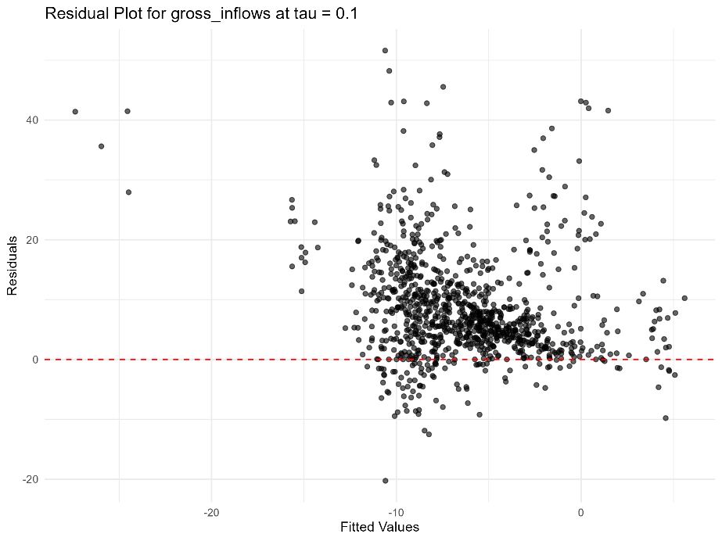
Figure A2: Residual plot for Gross Inflows at tau=0.25
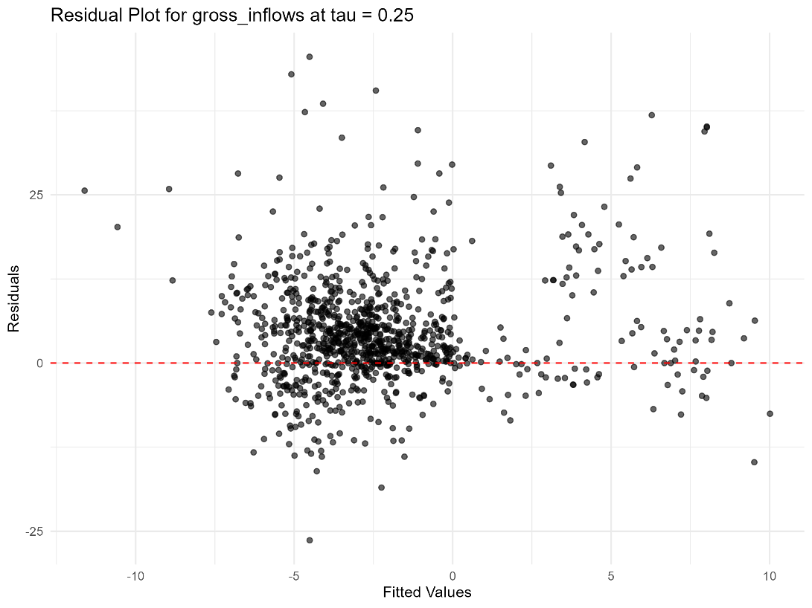
Figure A3: Residual plot for Gross Inflows at tau=0.5
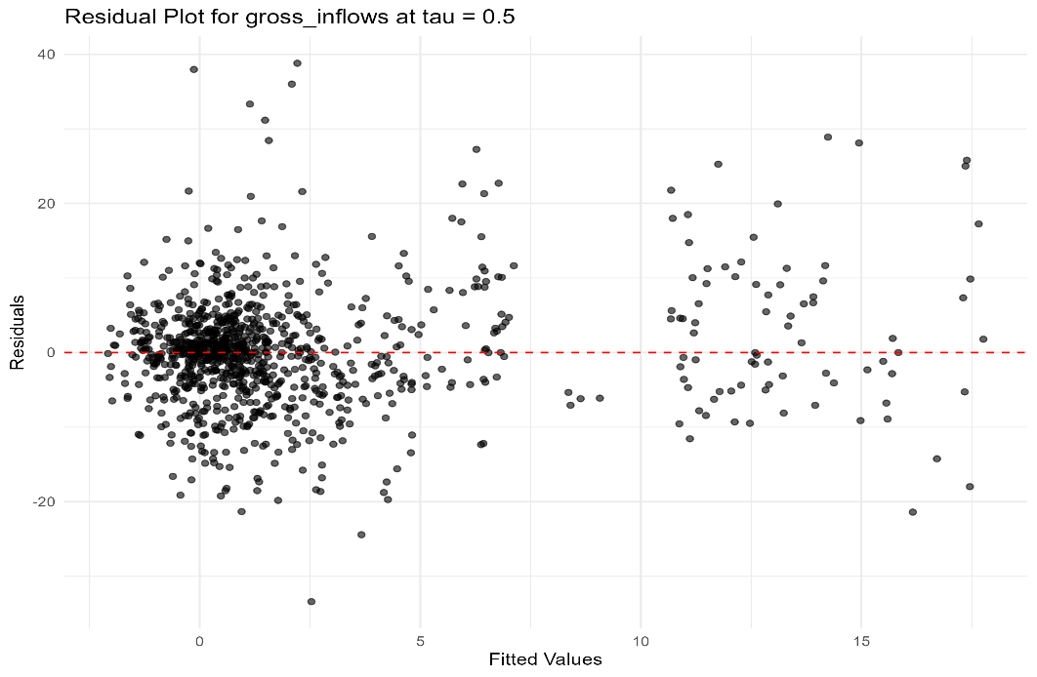
Figure A4: Residual plot for Gross Inflows at tau= 0.75
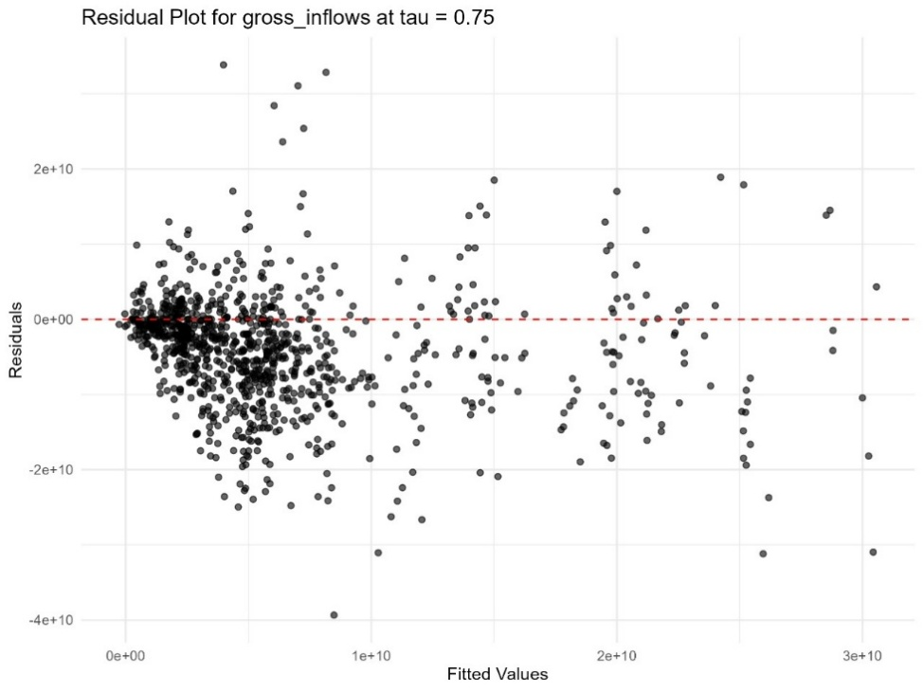

Figure A5: Residual plot for Gross Inflows at tau=0.9
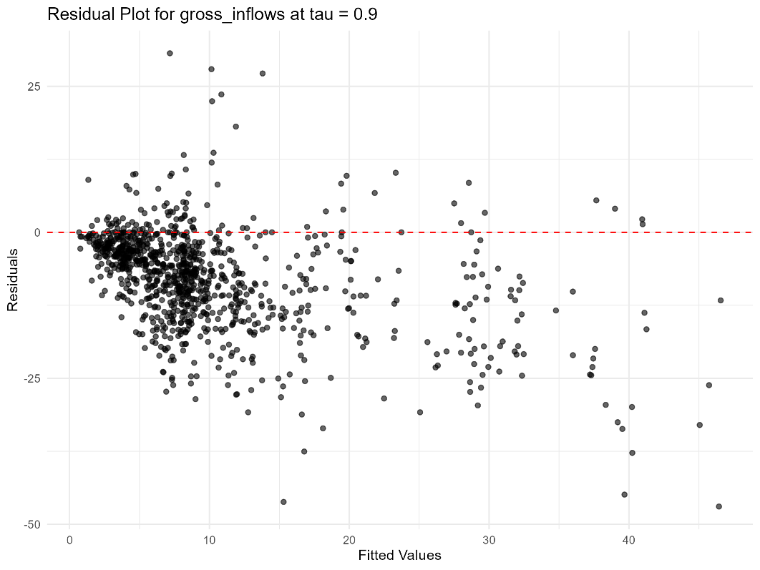

Figure A6: Residual plot for Gross Outflows at tau=0.1
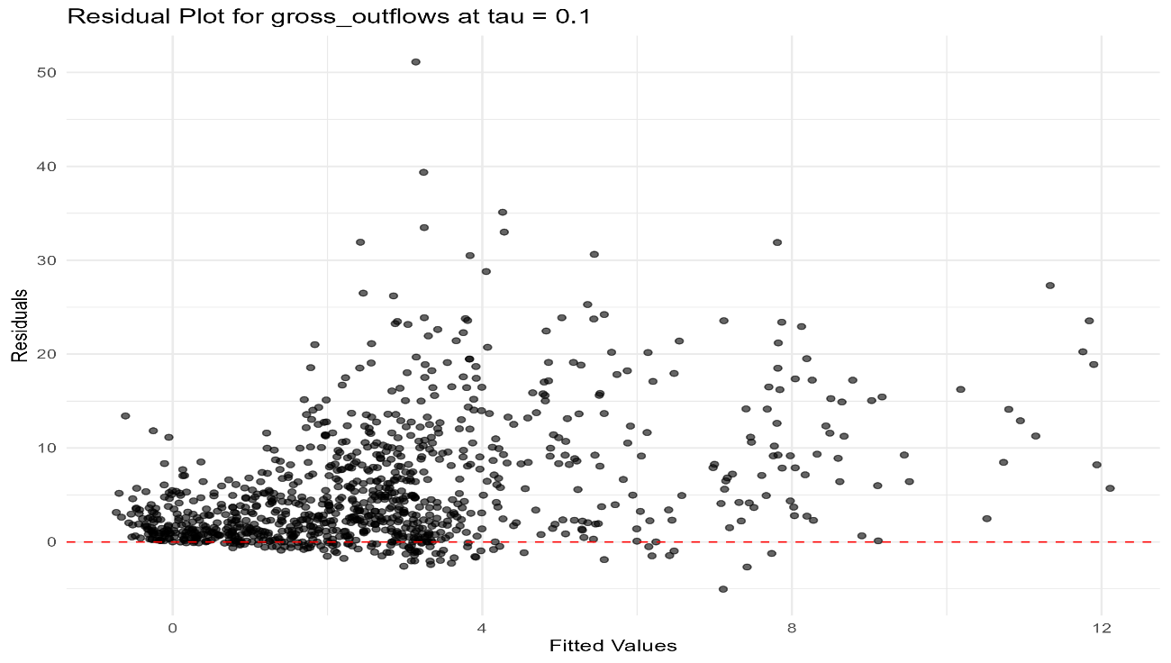

Figure A7: Residual plot for Gross Outflows at tau=0.25
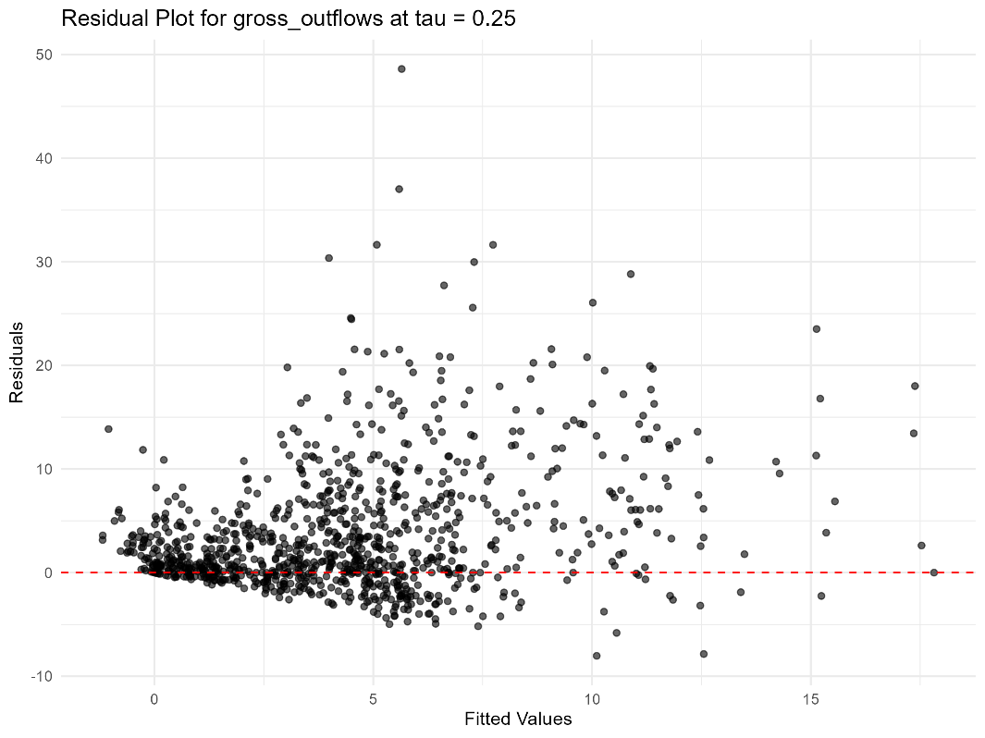

Figure A8: Residual plot for Gross Outflows at tau=0.5
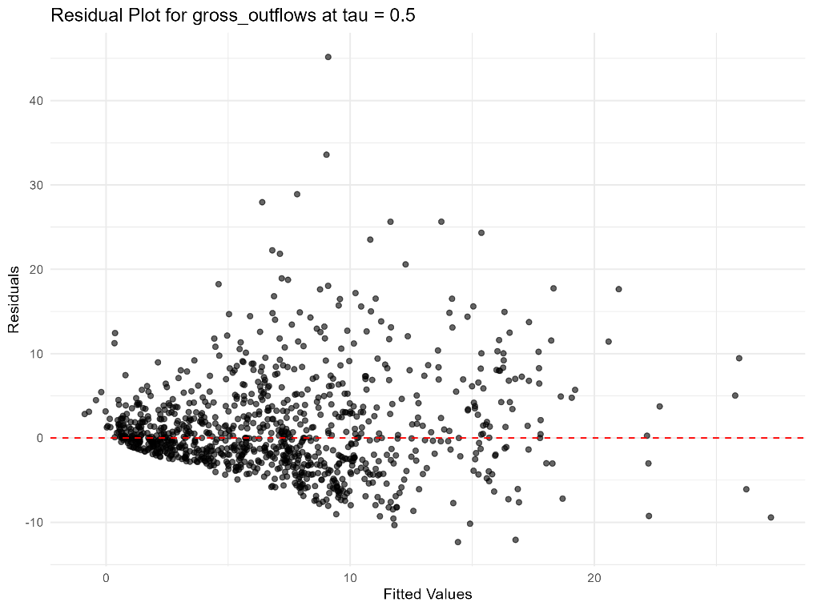

Figure A9: Residual plot for Gross Outflows at tau= 0.75
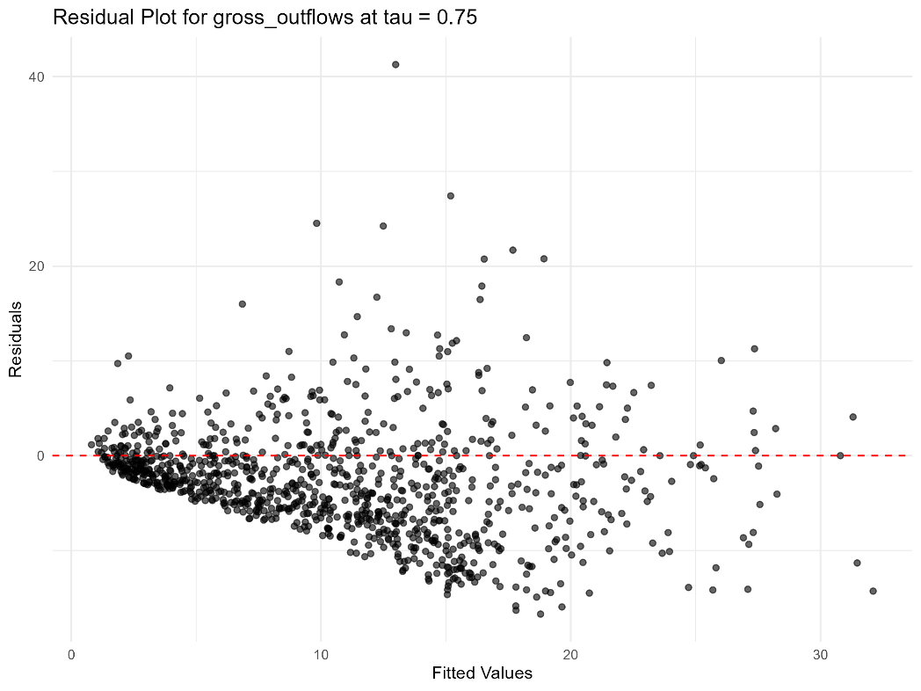

Figure 10: Residual plot for Gross Outflows at tau=0.9
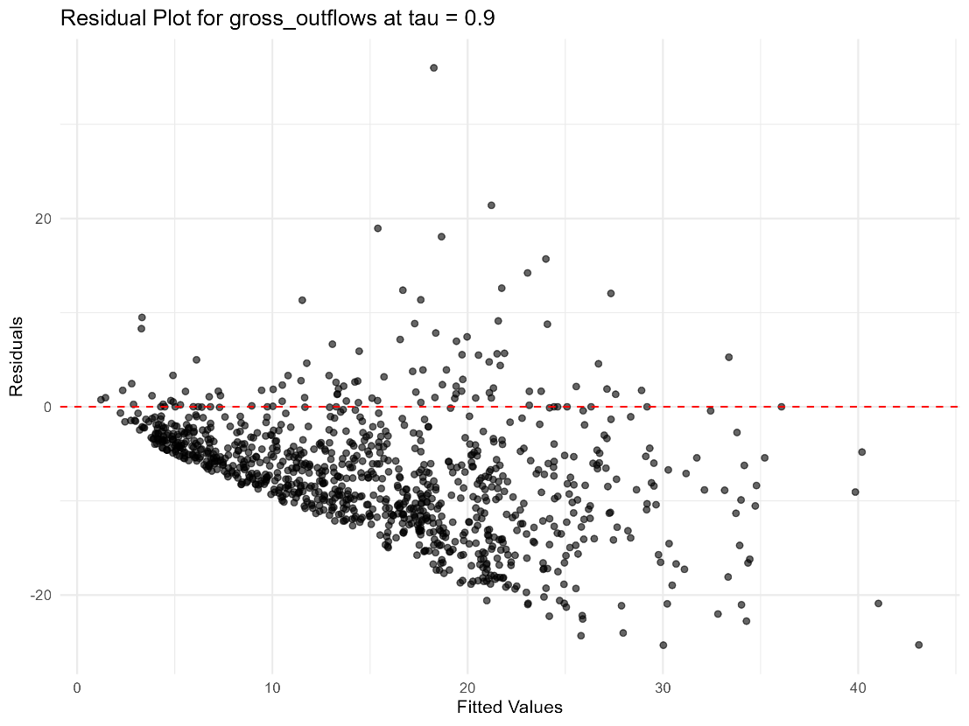

Figure A11: Residual plot for Net Inflows at tau=0.1
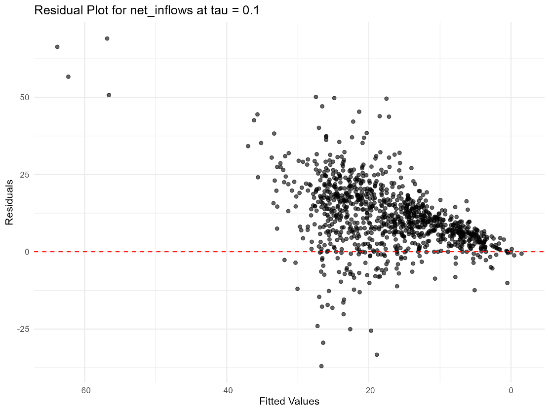

Figure A12: Residual plot for Net Inflows at tau=0.25
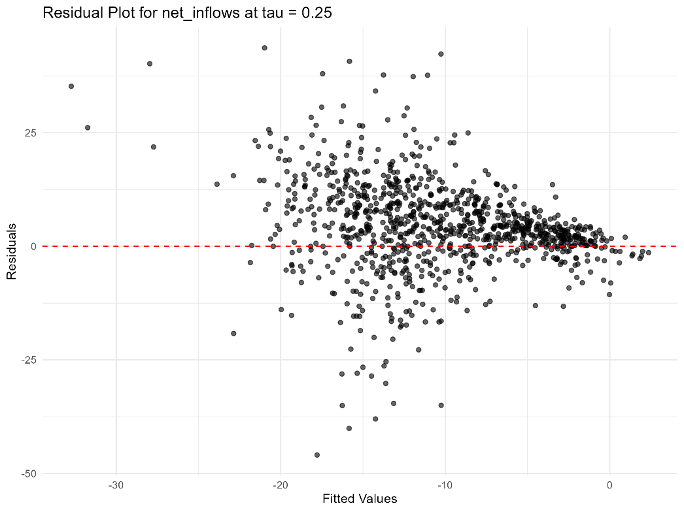

Figure A13: Residual plot for Net Inflows at tau= 0.5
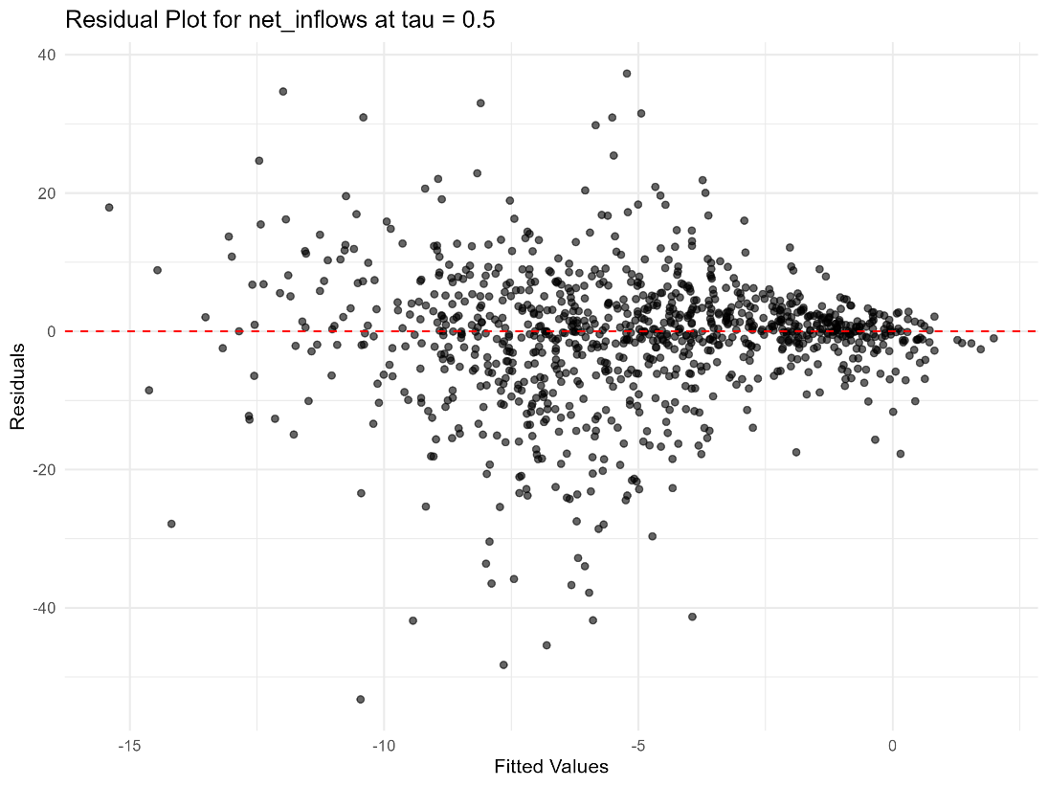

Figure A14: Residual plot for Net Inflows at tau=0.75
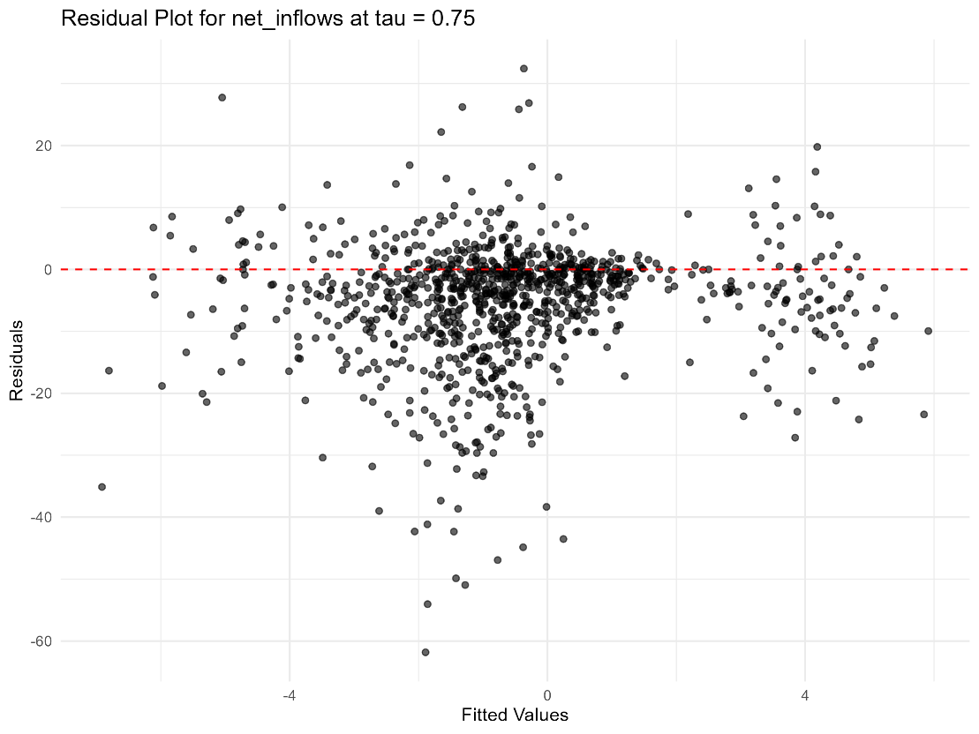

Figure A15: Residual plot for Net Inflows at tau= 0.9
